IT Department Digital Class Materials Management System

Abdullahi Ali Abdullahi
Abubakr Ali Abdulle
Zahra Abdirizak Omar
Mohamed Adam Ahmed
Abdullahi Isse Ahmed

SUBMISSION OF GRADUATION PROJECT FOR PARTIAL FULFILLMENT OF THE DEGREE OF BACHELOR OF SCIENCE IN COMPUTER APPLICATIONS JAMHURIYA UNIVERSITY OF SCIENCE AND TECHNOLOGY (JUST) FACULTY OF COMPUTER & INFORMATION TECHNOLOGY

AUGUST 2026

JAMHRURIYA UNIVERSITY OF SCIENCE AN TECHNOLOGY (JUST) ORIGINAL LITERARY WORK DECLARATION
Name of Candidate 1: ID No:
Name of Candidate 2: ID No:
Name of Candidate 3: ID No:
Name of Candidate 4: ID No:
Name of Degree: Bachelor Degree of Computer Application
Title of Project/Research Report/Thesis:
Field of Study:
We, the undersigned, do solemnly and sincerely declare that:
(1) We are the authors/writers of this Work.
(2) This Work is original.
(3) Any use of any work in which copyright exists was done by way of fair dealing and for permitted purposes and any excerpt or extract from, or reference to or reproduction of any copyrighted work has been disclosed expressly and sufficiently, and the title of the Work and its authorship have been acknowledged in this Work.
(4) We do not have any actual knowledge, nor do we ought reasonably to know that the making of this work constitutes an infringement of any copyrighted work.
(5) We hereby assign all and every right in the copyright to this Work to Jamhuriya University of Science and Technology (“JUST”), who henceforth shall be the owner of the copyright in this Work and that any reproduction or use in any form or by any means whatsoever is prohibited without the written consent of JUST having been first had and obtained.
(6) We are fully aware that if while making this Work, we have infringed any copyright whether intentionally or otherwise, we may be subject to legal action or any.

Candidate 1’s Signature: _________________________ Date: _____ /_____/________ Candidate 2’s Signature: _________________________ Date: _____ /_____/________ Candidate 3’s Signature: _________________________ Date: _____ /_____/________ Candidate 4’s Signature: ________________________ Date: _____ /_____/______
Subscribed and solemnly declared before, Supervisor’s
Name: __________________________ Date: _____/_____/_____________
Supervisor’s Signature: __________________ Designation: _______________________

ABSTRACT

The increasing use of digital technologies in higher education has created a need for structured systems that support the storage, organization, retrieval, and controlled distribution of academic materials. In the Department of Information Technology at Jamhuriya University, course materials are commonly distributed through WhatsApp, where files may become mixed with ordinary conversations and difficult to locate as chat histories grow. The department also lacks a centralized platform that organizes materials by academic year, semester, course, and chapter. This study therefore designed, implemented, and internally evaluated a containerized, full-stack Digital Class Materials Management System. The system provides a Next.js web application for administration, a React Native mobile application for students, a Flask REST API, a PostgreSQL database managed through SQLAlchemy, and Docker-based containerized deployment. It also integrates a Retrieval-Augmented Generation chatbot that enables students to query uploaded academic materials using natural language. The system was evaluated by the development team using predefined internal test cases covering functional correctness, mobile operation, device compatibility, API behavior, and selected security controls. All 15 functional tests, 10 mobile tests, five device-compatibility tests, 12 API tests, and eight selected security tests produced the expected outcomes. Test case TC-14 confirmed the chatbot’s functional integration by returning a context-relevant response based on selected academic material; however, comprehensive RAG-accuracy evaluation was outside the study’s scope. The results demonstrate that the system’s implemented functions operated correctly within the controlled testing environment. Formal User Acceptance Testing and independent security assessment remain necessary before full institutional deployment.
Keywords: Digital Class Materials Management; Full-Stack Development; Docker; Retrieval-Augmented Generation; Mobile Application; Internal System Testing

ACKNOWLEDGMENT
We extend our deepest gratitude to our supervisor, Mohamed Abdullahi Mohamud(shurie), for his unwavering support, patient guidance, and insightful feedback
throughout our research journey, which have been instrumental in shaping the quality and direction of this thesis. We are equally thankful to the Research Coordinator, Mohamed Abdullahi Mohamud, and the Assistant Research Coordinator, Abdullahi Mohamed Hassan, for their continuous assistance, encouragement, and timely guidance that contributed greatly to the smooth progress of this study. Our appreciation also goes to the faculty and staff in the Department of Bachelor of Computer Applications at Jamhuriya University of Science and Technology, whose resources and assistance have been invaluable. We would also like to acknowledge our peers for their companionship and the exciting discussions that inspired us throughout our academic journey. Their collective wisdom and encouragement have been a cornerstone of our research experience. We would like to acknowledge with sincere respect the exemplary leadership of our dean, Mohamed Abdullahi Ali, whose vision and encouragement have inspired us to strive for higher standards of academic achievement. Finally, we are profoundly grateful to the President of Jamhuriya University of Science and Technology, Mohamed Ahmed Mohamud, for his dedication to advancing higher education and research, as his leadership has created opportunities that enabled us to pursue and complete this academic endeavor.

Table of Contents
ABSTRACT iii
ACKNOWLEDGMENT iv
LIST OF FIGURES vii
LIST OF TABLES viii
LIST OF ABBREVIATIONS ix
CHAPTER I: INTRODUCTION 1
1.1 Background of the Study 1
1.2 Problem Statement 3
1.3 Research Objectives 4
1.4 Research Questions 5
1.5 Motivation of the Study 5
1.6 Significance of the Study 6
1.7 Scope of the Study 7
1.8 Organization of the Study 8
CHAPTER II: LITERATURE REVIEW 10
2.1 Introduction 10
2.2 Overview of Digital Class Materials Management Systems 11
2.2.1 Evolution of Academic Information Systems 12
2.2.2 Importance of DCMMS in Academic Institutions 14
2.2.3 Challenges in Existing Systems 15
2.3 Related Work 15
2.3.1 Learning Management Systems (LMS) 16
2.3.2 Digital Repositories and Scholarly Platforms 18
2.3.3 Web-Based and Mobile Academic Systems 19
2.3.4 Comparative Analysis of Reviewed Systems 20
2.4 Research Gap 22
2.4.1 Addressing the Research Gap 23
CHAPTER III: METHODOLOGY 26
3.1 Introduction 26
3.2 System Overview 26
3.3 System Features 26
3.4 System Architecture 27
3.5 System Requirements 28
3.5.1 Hardware Requirements 28
3.5.2 Software Requirements 29
3.5.3 Deployment Requirements 29
3.6 Requirements Specification 29
3.6.1 Functional Requirements 30
3.6.2 Non-Functional Requirements 32
3.7 Feasibility Study 33
3.7.1 Technical Feasibility: 33
3.7.2 Economic Feasibility: 33
3.7.3 Operational Feasibility: 34
3.7.4 Schedule Feasibility: 35
3.8 UML DIAGRAMS 35
3.8.1 Use Case Diagram 36
3.8.2 Activity Diagram 38
3.8.3 Sequence Diagram 41
3.9 DATABASE DESIGN 43
3.9.1 Database Tables 43
3.9.2 Entity Relationship (ER) Diagram 49
3.9.3 Role-Based Access Control (RBAC) 51
3.10 RAG Chatbot Design 52
3.10.1 System Components 53
3.10.2 Indexing Pipeline (Background Worker) 53
3.10.3 Reindexing of Pre-Existing Materials 54
3.10.4 Query Pipeline and Generation Modes 54
3.10.5 Offline/Online Boundary 55
3.10.6 Citation and Traceability 55
3.10.7 Hallucination Control 56
3.10.8 Functional Validation of the RAG Chatbot 56
3.11 Development Methodology 56
3.12 Internal System Evaluation Design 57
3.13 Testing Categories 57
3.14 Evaluation Procedure 57
3.15 Evidence Collection 57
3.16 Data Analysis Method 57
4.1 Introduction 58
4.2 Snapshots of the System 58
4.2.1 Web System Implementation and Testing 59
4.2.2 Mobile Application Implementation and Testing 66
4.2.3 Functional Testing 80
4.2.4 Internal UI/UX Heuristic Review 82
4.3 Backend and API Development and Testing 84
4.3.1 Backend Implementation 84
4.3.2 API Development 85
4.3.3 API Testing 85
4.4 Security Implementation and Testing 87
4.4.1 Authentication and Authorization 87
4.4.2 Input Validation 88
4.4.3 Security Testing 89
CHAPTER V: DISCUSSION AND CONCLUSION 92
5.1 Introduction 92
5.2 Discussion 92
5.2.1 System Performance Against Expectations 93
5.2.2 Effectiveness in Solving the Identified Problem 94
5.2.3 Comparison with Existing Studies and Systems 95
5.3 Conclusion 97
5.3.1 Achievement of Project Objectives 98
5.4 Limitations 100
5.4.1 Absence of Real End-User Evaluation 100
5.4.2 Limited Dataset for AI Chatbot Evaluation 100
5.4.3 Single Institutional Scope 101
5.4.4 Connectivity Assumptions 101
5.4.5 Time and Resource Constraints 101
5.5 Recommendations 102
5.5.1 Conduct Formal User Acceptance Testing 102
5.5.2 Expand AI Chatbot Capabilities 102
5.5.3 Implement Progressive Web App (PWA) Functionality 103
5.5.4 Introduce Lecturer-Facing Performance Analytics 103
5.5.5 Pursue Multi-Institutional and Cloud Deployment Architecture 103
5.5.6 Conduct a Formal Third-Party Security Audit 104
References 105

LIST OF FIGURES
Figure 3. 1: System Architecture Flow Diagram 28
Figure 3. 2: Use Case Diagram for DCMMS 37
Figure 3. 3:Activity Diagram for DCMMS 40
Figure 3. 4: Sequence Diagram for DCMMS 43
Figure 3. 5: ER Diagram for DCMMS 51
Figure 4. 1: Just Click Landing Page 60
Figure 4. 2: User Authentication (Sign In) Interface 61
Figure 4. 3: Administrator Dashboard Operational Overview 62
Figure 4. 4: Study Materials Browsing Interface Card Grid View 63
Figure 4. 5: Material Detail Page Hero Header Section 64
Figure 4. 6: Material Detail Page Metadata Panel and Quick Actions 65
Figure 4. 7: Just Click AI Chatbot Interface RAG-Powered Academic Assistant 66
Figure 4. 8: Just Click Mobile Application Authentication (Sign In) Screen 68
Figure 4. 9: Just Click Mobile Application Home / Landing Screen 69
Figure 4. 10:Just Click Mobile Application Study Materials Browsing Screen 70
Figure 4. 11: Just Click Mobile Application AI Chatbot (RAG-Powered) Screen 72
Figure 4. 12: Just Click Mobile Application Material Detail Screen 73
Figure 4. 13: Just Click Mobile Application Student Profile Screen 74
Figure 4.14: Mobile Downloads Screen 76

LIST OF TABLES
Table 2.1: Comparative Evaluation Against Design Criteria……………………………… 20
Table 4.1: Mobile Application Unit and Integration Test Cases 77
Table 4.2: Device Compatibility Testing Results 79
Table 4.3: Functional Test Cases for Just Click DCMMS 80
Table 4.4: API Endpoint Test Cases 86
Table 4.5: Security Test Cases and Results 89
Table 5.1: Project Objective Achievement Summary 98

LIST OF ABBREVIATIONS
Abbreviation | Meaning
AI | Artificial Intelligence
API | Application Programming Interface
ASP.NET | Active Server Pages .NET
CRUD | Create, Read, Update, Delete
DCMMS | Digital Class Materials Management System
DICT | Digital Information and Communication Technologies
DOCX | Document Open XML (Microsoft Word Format)
ER | Entity Relationship
GET | HTTP GET Method
GPRS | General Packet Radio Service
HTTP | Hypertext Transfer Protocol
IDE | Integrated Development Environment
IT | Information Technology
JSON | JavaScript Object Notation
JWT | JSON Web Token
LCMS | Learning Content Management System
LMS | Learning Management System
MERLOT | Multimedia Educational Resource for Learning and Online Teaching
MIME | Multipurpose Internet Mail Extensions
MIT | Massachusetts Institute of Technology
OAI-PMH | Open Archives Initiative Protocol for Metadata Harvesting
OCR | Optical Character Recognition
OCMMS | Online Course Material Management System
OOADM | Object-Oriented Analysis and Design Methodology
ORM | Object-Relational Mapping
OS | Operating System
OWASP | Open Web Application Security Project
PDF | Portable Document Format
PHP | Hypertext Preprocessor
POST | HTTP POST Method
PPT | PowerPoint Presentation
PPTX | PowerPoint Open XML Presentation
PWA | Progressive Web Application
RAG | Retrieval-Augmented Generation
RBAC | Role-Based Access Control
REST | Representational State Transfer
RESTful | Representational State Transfer (compliant)
RFC | Request for Comments
SQL | Structured Query Language
SSD | Solid State Drive
TAM | Technology Acceptance Model
UAT | User Acceptance Testing
UI | User Interface
UI/UX | User Interface / User Experience
UML | Unified Modeling Language
URL | Uniform Resource Locator
USB | Universal Serial Bus
UX | User Experience
VS Code | Visual Studio Code
WAMP | Windows, Apache, MySQL, PHP
XAMPP | Cross-Platform Apache, MySQL, PHP, Perl
XML | Extensible Markup Language
XSS | Cross-Site Scripting

CHAPTER I: INTRODUCTION

1.1 Background of the Study
The increasing adoption of digital technologies in higher education has created a growing need for structured systems that support the storage, organization, retrieval, and controlled distribution of academic materials. Digital Class Materials Management Systems provide centralized environments in which lecture notes, presentation slides, assignments, and other educational resources can be managed and accessed efficiently (Okon et al., 2020; Santos et al., 2025).
Traditionally, academic materials were maintained through printed documents, physical filing systems, and other manual storage methods. These approaches limited remote access, required physical storage space, and increased the risk of document loss, duplication, and deterioration. The introduction of digital repositories and Learning Management Systems improved material availability by enabling academic resources to be stored electronically and accessed by multiple users through web-based platforms (Triyana & Fianty, 2023; Okon et al., 2020).
Modern academic-resource systems increasingly use full-stack architectures consisting of user interfaces, backend services, databases, and application programming interfaces. This separation allows different system components to communicate through structured services and supports maintainability, integration, and future expansion. Containerization technologies such as Docker further support this architecture by packaging applications and their dependencies into consistent environments that can be used across development, testing, and deployment (Docker, Inc., n.d.)
Mobile access has also become important in digital education because many students use smartphones to access learning resources. Integrating mobile applications with the same backend services used by web platforms enables students to browse, search, and download academic materials from different locations and devices. This is particularly relevant in environments where smartphones provide a practical means of accessing digital educational content (Oladokun et al., 2025; Priyadarshini & Swamydoss, 2024).
Recent developments in artificial intelligence have introduced Retrieval-Augmented Generation as an approach for combining information retrieval with natural-language generation. A RAG system retrieves relevant content from an external document collection before generating a response, allowing its answers to be grounded in a defined knowledge source rather than relying entirely on the model’s internal knowledge (Lewis et al., 2020). Within an academic-material system, this approach can allow students to ask questions and receive explanations or summaries based on uploaded course documents.
In the Department of Information Technology at Jamhuriya University, course materials are commonly distributed through informal communication channels such as WhatsApp. Although these channels allow files to be shared quickly, they do not provide structured organization by academic year, semester, course, and chapter. Previously shared files may become difficult to locate as conversations grow, and the department lacks a centralized platform that combines academic-material management, mobile access, role-based authorization, and context-grounded retrieval.
These conditions establish the need for a secure, scalable, and accessible Digital Class Materials Management System. Accordingly, this study designs and implements a containerized full-stack platform consisting of a Next.js web application, a Flask REST API, a PostgreSQL database, a React Native mobile application, and a RAG chatbot grounded in uploaded academic materials.

1.2 Problem Statement
Academic institutions require centralized digital repositories that provide reliable access to academic materials and support organized storage and retrieval (Okon et al., 2020). However, informal communication platforms are still used to distribute learning materials in some higher-education environments.
In the Department of Information Technology at Jamhuriya University, course materials are commonly distributed through WhatsApp groups, either directly by lecturers or through class monitors. Although WhatsApp supports rapid communication, it is not designed as a structured academic-material repository. Files are mixed with ordinary conversations and are not consistently organized by course, semester, chapter, or material type.
As conversations accumulate, previously shared materials can become difficult to locate. Students may need to search through lengthy chat histories, depend on other group members, or request that materials be shared again. The existing approach also lacks centralized institutional storage, role-based access control, consistent material categorization, and intelligent retrieval of information from academic documents.
Studies have similarly identified limitations in using informal communication platforms for structured academic-content management, including weak organization, inefficient long-term retrieval, and limited integration with institutional academic processes (Oladokun et al., 2025; Okon et al., 2020).
Therefore, this study proposes the design and implementation of a containerized Digital Class Materials Management System for the Department of Information Technology at Jamhuriya University. The proposed system provides centralized storage, structured material organization, web and mobile access, role-based authorization, and a Retrieval-Augmented Generation chatbot for querying uploaded academic materials. The system is intended to reduce reliance on fragmented WhatsApp-based distribution and improve the accessibility and management of academic resources.

1.3 Research Objectives
General Objective
The general objective of this study is to design, implement, and internally evaluate a containerized, full-stack Digital Class Materials Management System for the Department of Information Technology at Jamhuriya University. The system aims to provide centralized and secure management of academic materials through a web-based administration interface, a mobile application for students, and a Retrieval-Augmented Generation chatbot that provides natural-language assistance grounded in uploaded academic content.
Specific Objectives
- To design and develop a secure digital class materials management system with role-based access for administrators and students that supports uploading, organizing, and retrieving academic resources (lecture slides, notes, and assignments) through web and mobile platforms.
- To implement and functionally validate a RAG chatbot that generates context-relevant answers grounded in the department’s uploaded academic materials.
- To develop a mobile application, using React Native, that allows students to browse, search, download, and query class materials from the same backend API used by the web platform.
- To evaluate the functional correctness, mobile compatibility, API behavior, and selected security controls of the proposed system using predefined internal test cases.

1.4 Research Questions
- How can a secure digital class materials management system be designed to support role-based storage, retrieval, and access to academic resources through web and mobile platforms?
- To what extent does the implemented RAG chatbot return context-relevant answers grounded in the department’s uploaded academic materials during internal functional testing?
- How can a mobile application integrated with the same backend API as the web platform enable students to browse, search, download, and query academic materials?
- To what extent does the proposed system satisfy its functional, mobile compatibility, API, and selected security requirements based on predefined internal test cases?

1.5 Motivation of the Study
The motivation for this study arises from the need for a centralized, reliable, and accessible platform for managing academic materials in the Department of Information Technology at Jamhuriya University. The current reliance on informal distribution channels such as WhatsApp makes materials difficult to organize by course, semester, and chapter. It also limits long-term retrieval and institutional control over academic resources.
Recent technological developments make a departmental solution practical and affordable. Containerization technologies such as Docker allow the web application, backend, database, and supporting services to be deployed consistently as an integrated environment. Similarly, modern web and mobile development frameworks make it possible to provide students with access to academic materials through both computers and smartphones.
The integration of Retrieval-Augmented Generation provides additional motivation for the project. Instead of functioning only as a digital file repository, the proposed system allows students to query uploaded materials using natural language and receive context-relevant academic assistance. The Information Technology Department provides an appropriate setting for implementing this solution because the system directly supports its academic-material workflow while demonstrating the practical application of full-stack development, mobile computing, containerization, and artificial intelligence within a single platform.

1.6 Significance of the Study
This study is significant because it demonstrates how a centralized digital platform can improve the management, accessibility, and retrieval of academic materials within a university department.
For students, the system provides a structured location where academic materials can be accessed through web and mobile platforms. Materials are organized by academic year, semester, course, and chapter, reducing reliance on informal communication channels. The integrated RAG chatbot also provides students with a natural-language method for obtaining assistance based on uploaded academic content.
For lecturers and academic staff, the system provides a more organized method of distributing and maintaining course materials. Centralized storage can reduce repeated file sharing, improve consistency in the materials available to students, and support better control over academic resources.
For the Department of Information Technology, the project provides a practical implementation of a containerized full-stack architecture using Flask, Next.js, PostgreSQL, React Native, and Docker. It demonstrates how web, mobile, database, and AI components can be integrated into a unified academic-material management platform.
For researchers and students in educational technology and software development, the study provides a documented case of integrating Retrieval-Augmented Generation into a departmental academic-resource system. Although formal end-user acceptance and large-scale RAG accuracy evaluations remain future work, the implemented system and internal testing results provide a foundation for further investigation.
Finally, future developers may use the system architecture, database design, API structure, mobile integration, internal testing approach, and identified limitations as a reference when developing or improving similar digital academic systems.

1.7 Scope of the Study
This study covers the design, development, and internal technical evaluation of a Digital Class Materials Management System for the Department of Information Technology at Jamhuriya University. Its scope is defined by the following boundaries.
Users and access control: The system supports two user roles: Administrator and Student. Administrators can manage user accounts, academic structures, and learning materials. Students can browse, search, view, download, save, share, and query available materials. Role-Based Access Control is applied to restrict each user to authorized functions.
Academic-material management: The system supports the uploading, organization, updating, retrieval, and downloading of lecture notes, presentation slides, assignments, and other approved academic resources. Supported file formats include PDF, DOC, DOCX, PPT, PPTX, and MP4. Materials are organized according to academic year, semester, course, and chapter.
System platforms: The system consists of a Next.js web application, a Flask REST API backend, and a React Native mobile application. The web application provides administrative and browser-based functions, while the mobile application provides students with mobile access to academic materials and chatbot services.
Data and file storage: Structured information, including user accounts, roles, academic metadata, material records, and interaction records, is stored in PostgreSQL through SQLAlchemy. Uploaded material files are maintained in filesystem-backed storage connected to the containerized application environment.
RAG chatbot: The chatbot generates context-grounded answers, explanations, summaries, quizzes, study plans, and study-question sets based on uploaded academic materials.
MP4 files can be stored and downloaded, but the current RAG indexing process is limited to text extracted from supported document and presentation files; automatic video transcription is outside the scope. The chatbot does not perform automated grading or formal assessment of student work.
Material tracking and reporting: The system records basic user interactions, including material views and downloads, and provides administrators with simple usage summaries. Advanced learning analytics, predictive analysis, student-performance measurement, and engagement scoring are outside the scope of the study.
Deployment scope: Docker and Docker Compose are used to package and coordinate the frontend, backend, database, and chatbot-indexing services. This supports consistency between development and intended deployment environments.
The study excludes payment processing, examination and grade management, plagiarism detection, automated student assessment, full offline browsing, and large-scale multi-institutional deployment. Previously downloaded files may be accessed offline, but browsing, searching, synchronization, and chatbot interaction require an active network connection.

1.8 Organization of the Study
Chapter I: Introduction presents the study background, problem statement, objectives, research questions, motivation, significance, scope, and overall organization.
Chapter II: Literature Review examines relevant concepts, technologies, studies, and existing academic-resource systems. It compares their capabilities and limitations and identifies the research and technical gaps addressed by the proposed system.
Chapter III: Methodology describes the system requirements, architecture, functional and non-functional requirements, feasibility analysis, UML models, database design, RAG chatbot design, Object-Oriented Analysis and Design Methodology, and internal system-evaluation approach.
Chapter IV: Implementation and Results presents the implemented web, mobile, backend, API, and security components. It also reports the results of the predefined functional, mobile, device-compatibility, API, and selected security test cases.
Chapter V: Discussion and Conclusion interprets the implementation and testing results in relation to the research objectives and identified problem. It summarizes the main findings, evaluates objective achievement, acknowledges the study’s limitations, and provides recommendations for future development and evaluation.

CHAPTER II: LITERATURE REVIEW

2.1 Introduction
The literature review constitutes a fundamental and indispensable component of academic research, as it provides a systematic and critical examination of existing knowledge, theoretical frameworks, technological developments, and methodological approaches related to a specific research problem (Okon et al., 2020). In this study, the focus is placed on Digital Class Materials Management Systems (DCMMS), which are designed to facilitate the structured storage, management, retrieval, and dissemination of academic resources in digital form across educational institutions.
The rapid advancement of digital technologies has significantly transformed the educational sector, resulting in the emergence of highly interconnected learning ecosystems that depend on robust digital infrastructures for content delivery, communication, and collaboration (Santos et al., 2025). Consequently, academic institutions are increasingly required to adopt scalable, secure, and efficient systems capable of handling large volumes of educational data while supporting diverse user interactions, including students, lecturers, and administrative staff (Okon et al., 2020). Historically, educational institutions relied on manual record-keeping systems and physical storage mechanisms such as printed lecture notes, textbooks, and paper-based archives. These traditional approaches were inherently limited in terms of accessibility, scalability, and durability, often resulting in inefficiencies in information retrieval and increased risk of data loss or degradation (Fuentes et al., 2012). Furthermore, such systems were not designed to support collaborative or remote learning environments, which are now essential in modern education.
With the introduction of web-based technologies, educational systems evolved into digital repositories and Learning Management Systems (LMS), which significantly improved the accessibility and organization of academic content (Ghoniemy et al., 2010). However, despite these improvements, many existing systems remain constrained by monolithic architectures, limited interoperability, weak mobile integration, and inefficient deployment strategies.
Recent advancements in software engineering, particularly in full-stack development, RESTful API design, microservices architecture, and containerization technologies such as Docker, have introduced new paradigms for building scalable and maintainable academic systems (Naresh & Pavan, 2024). These technologies provide the foundation for modern Digital Class Materials Management Systems that emphasize flexibility, scalability, and real-time accessibility.
Therefore, this literature review critically analyzes existing systems, identifies their strengths and limitations, and establishes the conceptual and technical foundation for the proposed containerized Digital Class Materials Management System. In addition to traditional digital learning systems, recent advancements in Artificial Intelligence have introduced Retrieval-Augmented Generation (RAG) models. These models enhance information retrieval systems by combining document retrieval with generative AI capabilities, allowing users to receive accurate, context-aware responses based on stored academic content. This approach is increasingly being adopted in modern educational platforms to improve search efficiency and user interaction

2.2 Overview of Digital Class Materials Management Systems
Digital Class Materials Management Systems (DCMMS) are advanced information systems designed to centralize, organize, and distribute academic content in a structured digital environment (Okon et al., 2020).These systems support the efficient handling of educational materials such as lecture notes, assignments, multimedia resources, research documents, and project files.
DCMMS plays a crucial role in modern educational transformation by enabling continuous access to learning materials regardless of time and location. This capability supports both traditional classroom learning and modern hybrid or fully online learning environments (Santos et al., 2025).. Additionally, DCMMS improves academic collaboration, enhances administrative efficiency, and ensures better management of institutional knowledge resources.
From a technological perspective, DCMMS integrates multiple layers of software architecture, including frontend interfaces, backend services, and database systems. These layers work together to ensure seamless interaction between users and academic resources.

2.2.1 Evolution of Academic Information Systems
The evolution of academic information systems reflects the broader transformation of educational methodologies and technological capabilities over time. This evolution can be categorized into three major phases:
a) Manual Systems Era
During the manual systems era, educational institutions relied entirely on physical documentation methods such as printed lecture notes, handwritten assignments, physical libraries, and paper-based filing systems (Okon et al., 2020).Although these systems were straightforward and required minimal technological infrastructure, they presented significant limitations.
Key limitations of the traditional system included limited accessibility to academic materials, a high risk of physical damage or loss of documents, and inefficient retrieval processes that required manual searching. The system also lacked scalability to accommodate growing student populations and provided no support for remote learning or collaboration. As student populations increased, these limitations became more pronounced, thereby highlighting the need for digital transformation to improve accessibility, efficiency, and the overall management of academic resources.
b) Digital Transition Era
The digital transition era marked the introduction of early computerized systems and basic Learning Management Systems (LMS). These systems digitized academic processes and introduced centralized storage of educational content (Ghoniemy et al., 2010).
Despite these improvements, early digital systems still had several limitations, including dependence on local server installations, limited integration among different academic tools, poor scalability for large institutions, minimal support for mobile devices, and a lack of real-time synchronization. Although this phase represented an important step toward modernization, these limitations made the systems insufficient to meet the evolving demands of contemporary education, thereby highlighting the need for more advanced and integrated digital solutions.
c) Modern Full-Stack and Cloud Era
The modern era is characterized by the adoption of advanced software engineering principles, including cloud computing, microservices architecture, RESTful APIs, and containerization technologies such as Docker (Naresh & Pavan, 2024). These technologies enable the development of highly scalable, distributed, and resilient academic systems.
Key characteristics of this era include real-time data synchronization across devices, cross-platform accessibility through both web and mobile platforms, modular system architecture, scalable deployment using containers, and improved system security and maintainability. This evolution demonstrates a clear shift toward flexible and intelligent academic systems capable of supporting modern educational demands by enhancing accessibility, scalability, efficiency, and the overall reliability of digital learning environments.

2.2.2 Importance of DCMMS in Academic Institutions
Digital Class Materials Management Systems provide several critical benefits that enhance teaching, learning, and institutional management (Okon et al., 2020).
Key importance of the system includes centralized storage and management of academic materials, which ensures that all learning resources are organized and easily maintained within a single platform. It also improves accessibility by allowing students and instructors to access learning materials anytime and from any location, thereby supporting flexible learning. In addition, the system enhances collaboration between students and instructors by providing a shared digital environment for communication and resource exchange. It reduces dependency on physical storage infrastructure, which minimizes risks related to document loss or damage.
Furthermore, the system supports hybrid, remote, and blended learning models, making it suitable for modern educational environments. It also increases the efficiency of academic administration and resource distribution by automating and streamlining key processes. Ultimately, improved availability of academic resources contributes to better student engagement and enhanced academic performance.
In technical disciplines such as Information Technology, the importance of DCMMS is even greater due to the complexity of materials, which often include programming code, technical documentation, software tools, and project-based learning resources (Naresh & Pavan, 2024).

2.2.3 Challenges in Existing Systems
Despite significant technological advancements, existing academic systems continue to face several critical challenges that hinder optimal performance and user experience.
These challenges include:
These challenges include limited scalability under high concurrent user loads(Naresh & Pavan, 2024), a lack of real-time synchronization between users and systems(Santos et al., 2025), and weak integration between web and mobile platforms (Oladokun et al., 2025), In addition, security vulnerabilities in data sharing and authentication mechanisms (Ghoniemy et al., 2010),further compromise system reliability. Many existing systems also depend on outdated deployment environments such as XAMPP or (Triyana & Fianty, 2023), which limits flexibility and modern deployment practices. Furthermore, poor user experience resulting from outdated interface design in legacy systems negatively affects usability and adoption.
Moreover, there is limited adoption of intelligent retrieval mechanisms such as Retrieval-Augmented Generation (RAG), which results in reduced accuracy in information retrieval and user interaction. Collectively, these limitations indicate the necessity for modern, modular, and containerized systems that are capable of effectively addressing scalability, security, and interoperability challenges in contemporary academic environments.

2.3 Related Work
This section provides a comprehensive and critical analysis of existing systems and research studies related to Digital Class Materials Management Systems. Each system is evaluated in terms of architecture, technology stack, achievements, limitations, and relevance to the proposed system. Recent research in educational technology highlights the growing use of Artificial Intelligence (AI) in learning systems. In particular, Retrieval-Augmented Generation (RAG) models are being explored to improve the accuracy and relevance of information retrieval by combining document search with generative AI responses. However, many existing academic systems still rely on traditional retrieval techniques and have not fully integrated RAG-based solutions.

2.3.1 Learning Management Systems (LMS)
Learning Management Systems such as Moodle and Blackboard are widely adopted platforms used in educational institutions for managing teaching and learning (Dobrzański et al., 2006). These systems provide functionalities such as course management, assignment submission, grading systems, communication tools, and assessment modules.

2.3.1.1 Architecture Analysis
Most LMS platforms are built using monolithic architectures where all system components are tightly integrated into a single application. For example, Moodle is developed using PHP and MySQL, while Blackboard is based on ASP.NET enterprise architecture (Dobrzański et al., 2006)
This monolithic structure results in:
- Tight coupling of system components
- Difficulties in scaling individual modules
- Complex maintenance and updates
- Limited flexibility for customization

2.3.1.2 Achievements
Despite architectural limitations, LMS platforms have achieved significant success:
- Support for millions of users globally (Fuentes et al., 2012). Structured learning environment for academic institutions
- Support for synchronous and asynchronous learning modes
- Wide adoption across universities and colleges worldwide

2.3.1.3 Limitations
However, LMS platforms exhibit several limitations:
- High system complexity and maintenance cost (Ghoniemy et al., 2010).
- Expensive proprietary licensing models (Sejzi & Aris, 2013).
- Lack of flexibility for departmental customization
- Feature overload leading to usability challenges
- Heavy system requirements

2.3.1.4 Critical Evaluation
While LMS platforms such as Moodle and Blackboard are robust and widely adopted, their monolithic architecture is a structural rather than incidental limitation: because presentation, business logic, and data access are compiled into a single deployable unit (Dobrzański et al., 2006), scaling the materials-management function independently of, say, the grading or communication modules is not architecturally possible without scaling the entire application. This makes such platforms poorly suited to a department that needs only materials management and intelligent retrieval, not a full institutional LMS suite adopting Moodle for this purpose would import unnecessary complexity (grading, enrollment, communication tools) that this study's scope explicitly excludes. The proposed system's modular Flask/Next.js separation avoids this by allowing the materials-management and RAG components to be deployed, scaled, and maintained independently of one another as separate Docker services.

2.3.2 Digital Repositories and Scholarly Platforms
Digital repositories such as DSpace and MERLOT are designed for long-term preservation and dissemination of academic research outputs (Okon et al., 2020; Orhun, 2004) .

2.3.2.1 Architecture Analysis
These systems use metadata-driven architectures based on standards such as Dublin Core for organizing and retrieving academic content. They emphasize structured storage and archival management of digital resources (AalYateem & Hameed, 2015).

2.3.2.2 Achievements
- Long-term preservation of academic resources
- Global accessibility of scholarly outputs
- Standardized metadata organization
- Large-scale institutional adoption

2.3.2.3 Limitations
- Static archival nature with limited interactivity
- Lack of real-time collaboration features
- Weak or no mobile-first design
- Limited integration with modern academic workflows
Institution-specific deployments illustrate this pattern concretely: across five university repositories reviewed Alexandria, Damascus, Khartoum, Nayef, and King Fahd University of Petroleum and Minerals common weaknesses include incomplete repository policies, limited or single-language interface support, and an absence of social or collaborative features (AalYateem & Hameed, 2015).

2.3.2.4 Critical Evaluation
Digital repositories such as DSpace-based systems are architecturally optimized for a different problem than the one this study addresses: long-term archival preservation and metadata-standard compliance (e.g., Dublin Core, OAI-PMH), not day-to-day classroom material circulation. Their static, submission-then-archive workflow (AalYateem & Hameed, 2015) assumes infrequent additions curated for permanence, whereas a departmental materials system requires frequent, low-friction uploads from multiple lecturers on an ongoing basis. Retrofitting real-time class material distribution onto an archival repository would require working against, rather than with, its core design assumption. This distinction archival system versus operational system is the technical justification for treating repositories as inapplicable to this study's problem, rather than merely "improvable."

2.3.3 Web-Based and Mobile Academic Systems
Modern academic systems such as Online Course Material Management Systems (OCMMS) and student portal applications utilize full-stack technologies including React, Node.js, and RESTful APIs (Naresh & Pavan, 2024).

2.3.3.1 Architecture Analysis
These systems follow a decoupled architecture where frontend and backend components are separated. This improves scalability, maintainability, and flexibility.

2.3.3.2 Achievements
- Improved user experience and interface responsiveness
- Real-time updates and notifications
- High user satisfaction rates (above 90% in UAT studies)
- Remote access to academic materials

2.3.3.3 Limitations
- Dependence on local development environments (XAMPP/WAMP)
- Lack of enterprise-level deployment strategies
- Weak containerization support
- Incomplete mobile application integration

2.3.3.4 Critical Evaluation
Systems such as OCMMS demonstrate that a decoupled, full-stack architecture is achievable, and their reported UAT satisfaction rates above 90% (Naresh & Pavan, 2024) show that departmental-scale systems can achieve strong usability. However, the same study's testing was confined to local development stacks (XAMPP), meaning its deployment consistency across environments the primary problem containerization solves was never actually evaluated. This is a specific and correctable gap, not a general shortcoming: the architecture pattern (decoupled frontend/backend) is sound and is retained in the proposed system, while the deployment layer is replaced with Docker specifically to close this evaluated-but-unresolved gap.

2.3.4 Comparative Analysis of Reviewed Systems

Table 2.1: Comparative Evaluation Against Design Criteria
System | Modular architecture | Containerized deployment | Mobile-native | Real-time sync | Intelligent (RAG) retrieval | Consistent deployment
Moodle Blackboard (LMS) | No monolithic | No | Limited (responsive web only) | Partial | No | Varies by institution
DSpace repositories (IMSU, Damascus, Khartoum, etc.) | Partial (metadata-driven) | No | No | No | No | Institution-dependent
OCMMS (Naresh & Pavan, 2024) | Yes | No | Partial | Not specified | No | Tested only on XAMPP
Student Portal (Priyadarshini & Swamydoss) | Partial | No | Yes (Android only) | Not specified | No | Local server only
WhatsApp Pedagogical Model | N/A (not a system) | N/A | Yes (via existing app) | Yes | No | N/A
Proposed system | Yes | Yes | Yes (web + mobile) | Partial (planned) | Yes (RAG) | Docker-based, environment-independent

2.4 Research Gap
The comparative analysis in Table 2.1 and the critical evaluations above indicate that existing gaps in academic materials management systems fall into three distinct categories, rather than a single undifferentiated list of shortcomings.
Architectural and deployment gaps. LMS platforms remain monolithic (Dobrzański et al., 2006), and even architecturally decoupled systems such as OCMMS have not been evaluated beyond local development environments (Naresh & Pavan, 2024), leaving deployment consistency across institutional settings largely untested in the literature.
Integration gaps. Mobile support across reviewed systems is either absent (DSpace-based repositories), partial and platform-specific (the Android-only student portal of Priyadarshini & Swamydoss), or achieved only informally through general-purpose messaging tools rather than a purpose-built application (Oladokun et al., 2025). No reviewed system provides mobile access as a first-class, integrated component of a purpose-built materials-management architecture.
Retrieval intelligence gaps. None of the reviewed systems including those with strong archival or usability performance implement Retrieval-Augmented Generation or comparable context-aware retrieval. Existing systems rely on either manual browsing (repositories, LMS file directories) or basic keyword search, with no mechanism for natural-language querying, summarization, or self-assessment generation grounded in institutional content.
Critically, these three gaps have historically been addressed in isolation by different systems, never in combination. This fragmentation is itself evidence of the gap: institutions seeking modular deployment must sacrifice mobile integration (as in repository systems), and institutions seeking intelligent retrieval have no reviewed precedent at all. The proposed system's necessity therefore rests not on any single unmet capability, but on the absence, in the reviewed literature, of a system that unifies containerized modular deployment, integrated mobile access, and RAG-based intelligent retrieval within one department-scale architecture the specific combination required by the problem established in Chapter I for the Department of Information Technology at Jamhuriya University.

2.4.1 Addressing the Research Gap
The proposed system addresses each of the three gap categories identified above through the following architectural decisions:
Addressing architectural and deployment gaps:
- Flask and Next.js are used in a decoupled backend/frontend architecture, avoiding the monolithic coupling identified in LMS platforms (Section 2.3.1).
- Docker is used for containerized deployment, directly addressing the deployment-consistency gap left unresolved even in architecturally modern systems such as OCMMS, whose testing was confined to local development stacks (Section 2.3.3).
- PostgreSQL, accessed through SQLAlchemy as an ORM layer, provides a relational data layer independent of any specific server environment, supporting the same consistent-deployment goal.
Addressing integration gaps:
- A mobile application, built on the same RESTful API layer used by the web platform, provides first-class mobile access rather than the partial or informal mobile support observed in reviewed systems (Section 2.3.4, Table 2.1).
- RESTful APIs mediate all client-server communication, ensuring the web and mobile clients remain consistent with one another rather than diverging, as occurred in platform-specific systems such as the Android-only student portal reviewed in Section 2.3.3.
Addressing retrieval intelligence gaps:
- A Retrieval-Augmented Generation (RAG) pipeline combining a local embedding model, ChromaDB vector search, and the DeepSeek API for generation retrieves relevant content from institutional materials before generating a response, addressing the absence of intelligent retrieval identified across every reviewed system category, including repositories, LMS platforms, and web/mobile portals alike (Section 2.4).
- This grounding in retrieved institutional content, combined with explicit prompt constraints restricting responses to that context, is intended to improve answer relevance and reduce hallucination risk relative to an ungrounded chatbot.
Taken together, these design decisions are intended to close the specific combination of gaps established in Section 2.4 not any single capability in isolation, but the simultaneous achievement of modular deployment, integrated mobile access, and intelligent retrieval within one departmental system.

CHAPTER III: METHODOLOGY

3.1 Introduction
This chapter presents the methodology and technical framework used in developing the IT Department Digital Class Materials Management System (DCMMS). It outlines the system description, features, development approach, architecture, hardware and software requirements, user requirements, database design, and modeling techniques. The chapter provides a structured framework for understanding how the proposed system will achieve the research objectives while ensuring a secure, scalable, and efficient platform for managing and accessing academic materials.

3.2 System Overview
A web-based academic system is designed to provide a centralized platform that supports the management and distribution of educational resources within an institution. It enables Admin to upload and organize academic materials such as lecture notes, assignments, and course resources in a structured and accessible manner. At the same time, Students access these materials primarily through the mobile application, while the web platform is designed for administrators to manage and upload content. Where students access the system through a web browser, this is treated as a secondary access channel rather than the primary intended interface, consistent with the platform allocation defined in Section 1.7.

3.3 System Features
The system incorporates several key functional modules that collectively support efficient academic management and user interaction. It includes an authentication system to ensure secure login and access control for different users within the platform. The upload and download functionality allow administrators to share academic materials while enabling students to access them easily. Course management features are provided to organize subjects, modules, and related learning content in a structured manner.
In addition, the system implements Role-Based Access Control (RBAC) to define and restrict user permissions based on roles such as admin, and student, ensuring data security and proper system usage. Material tracking functionality is included to monitor access, updates, and usage of uploaded resources. Email notifications are also integrated to provide timely updates regarding system activities such as new uploads or announcements.
Furthermore, the system incorporates an AI-powered chatbot based on Retrieval-Augmented Generation (RAG), which enhances the platform by enabling intelligent search and question-answering capabilities. This allows users to retrieve relevant academic information more efficiently and improves overall user experience and system interactivity.

3.4 System Architecture
The system follows a client–server architecture, deployed as a multi-container Docker Compose stack. Two client types consume the same backend API a web client built with Next.js, used by administrators, and a mobile client built with React Native, used by students. The web client is served by the Next.js frontend container, while the mobile app calls the Flask REST API directly, so both clients share a single source of business logic.
The Docker Compose environment orchestrates four containers on an internal network: the Next.js frontend, the Flask backend API (handling authentication and RBAC, academic and material management, the chatbot controller, file management, notifications, and audit logging), the PostgreSQL database, and the chatbot indexing worker. The indexing worker and backend share two persistent volumes outside the application containers: ChromaDB, the vector store used for semantic retrieval, and the locally downloaded embedding model. Three services sit outside the Docker environment: file storage for uploaded materials, the email service for system notifications, and the DeepSeek API, which is the only component requiring external network connectivity embedding generation and vector retrieval run entirely on local infrastructure once set up.
Figure 3.1 illustrates this architecture, including the client layer, the Docker-orchestrated container boundary, persistent volumes, and external service dependencies.

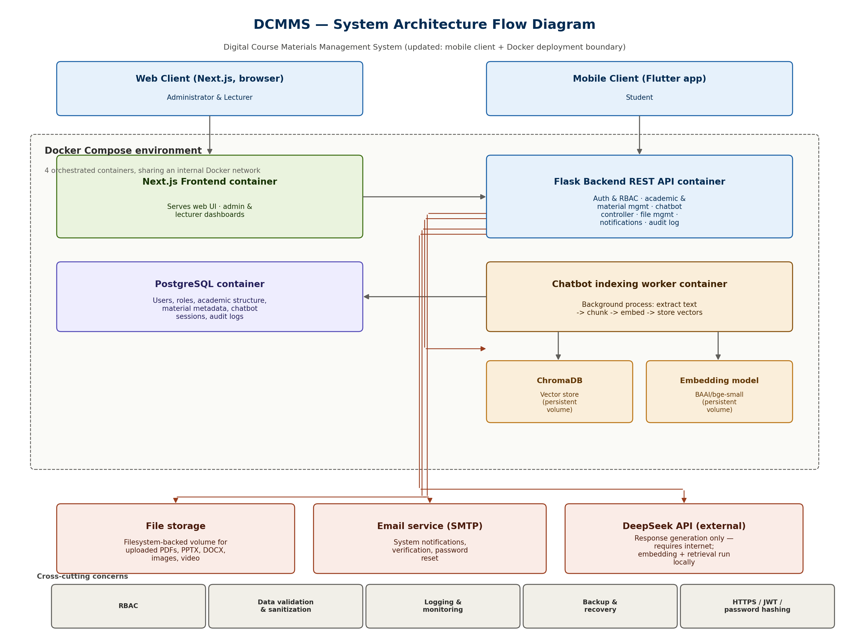
Figure 3. 1: System Architecture Flow Diagram

3.5 System Requirements

3.5.1 Hardware Requirements
- Intel i5 processor or equivalent (minimum 4 cores recommended for running the Docker Compose stack alongside the embedding model)
- Minimum 8GB RAM (16GB recommended, since the embedding model and ChromaDB both hold data in memory during indexing)
- 256GB SSD, with at least 10GB reserved for the ChromaDB vector store and embedding model files, which grow with the size of the materials corpus

3.5.2 Software Requirements
- VS Code or equivalent IDE
- Flask (backend framework), Next.js (frontend framework), PostgreSQL (relational database), SQLAlchemy (ORM)
- Docker and Docker Compose, for container orchestration across the application, database, and AI service layers
- ChromaDB (vector database), BAAI/bge-small-en-v1.5 (embedding model, downloaded locally)
- DeepSeek API access (external dependency requiring a valid API key and network connectivity)

3.5.3 Deployment Requirements
The system is deployed as a multi-container Docker Compose stack consisting of four services: the Next.js frontend, the Flask API backend, the PostgreSQL database, and the background indexing worker, with ChromaDB and the embedding model mounted as persistent volumes accessible to both the backend and worker containers.

3.6 Requirements Specification
The requirements specification defines the functional and non-functional requirements of the proposed system. It provides a clear description of what the system is expected to achieve and the constraints under which it operates. These requirements ensure that the system is developed in alignment with user needs, institutional objectives, and technical feasibility.

3.6.1 Functional Requirements
The following functional requirements describe the key functionalities supported by the platform.
1. Login System
The system shall provide a secure authentication mechanism that allows users to log in using valid credentials. It shall verify user identity and grant access based on assigned roles such as Administrator or Student.
2. User Registration, Email Verification, and Account Approval
The system shall allow new students to register by providing the required personal and academic information. After registration, the system shall send an email verification link or verification code to the student's registered email address. Once the student verifies their email, the registration request shall be submitted to the administrator for review and approval. Upon approval, the system shall automatically create the student's account and send the assigned User ID and temporary password to the student's verified email address. Only approved students shall be permitted to access the system.
3. User and Access Management
The system shall enable administrators to manage user accounts, roles, permissions, and access privileges. The system shall implement Role-Based Access Control (RBAC) to ensure that users can only access authorized resources and functionalities.
4. Academic Structure Management
The system shall allow administrators to manage academic entities including faculties, departments, academic years, semesters, courses, course offerings, and course chapters. This functionality ensures proper organization and management of educational content.
5. Learning Material Management
The system shall enable administrators to upload, organize, update, and manage educational materials such as lecture notes, documents, presentations, and other learning resources. All materials shall be stored securely and categorized according to courses and chapters.
6. Material Access and Download
The system shall allow students to access, view, search, and download learning materials related to their courses. Access to educational resources shall be controlled through authentication and authorization mechanisms.
7. Material Interaction Tracking
The system shall record student interactions with learning materials, including views and downloads. This information shall be used for monitoring engagement and generating system analytics.
8. AI-Powered RAG Chatbot
The system shall provide an AI-powered Retrieval-Augmented Generation (RAG) chatbot that enables students to interact with educational content using natural language queries. The chatbot shall retrieve relevant information from stored learning materials and generate context-aware responses.
9. Chat Session Management
The system shall maintain chatbot conversation sessions and message histories to support continuous interactions and improve user experience.
10. Search Functionality
The system shall provide search capabilities that allow users to locate courses, chapters, and educational materials efficiently. The RAG chatbot shall enhance the search process through intelligent information retrieval.
11. Notification and Communication Services
The system shall support automated notifications and system-generated communications, including alerts, updates, and informational messages where applicable.
12. Basic Usage Reporting
The system shall provide administrators with basic reports derived directly from logged access events such as view/download counts per material and per course presented as simple tabular summaries. This is distinct from advanced analytics (e.g., predictive usage trends, engagement scoring, or dashboard visualizations), which are explicitly outside the scope of this study as defined in Section 1.7.

3.6.2 Non-Functional Requirements
Non-functional requirements define the quality attributes and constraints of the system.
- Performance: The system should provide responsive interaction under normal departmental use. Formal response-time benchmarking and concurrent-load testing are outside the current evaluation scope and are recommended before institutional deployment
- Security: The system shall implement secure authentication and authorization mechanisms to protect user data and prevent unauthorized access.
- Scalability: The system shall be designed to accommodate future growth in users, data volume, and system features.
- Reliability: The system shall ensure high availability and minimize downtime during operation.
- Usability: The system shall provide a user-friendly interface that is easy to navigate for all categories of users.
- Maintainability: The system shall be developed using modular architecture to allow easy updates and maintenance.
- Compatibility: The system shall be compatible with modern web browsers and responsive across different devices.

3.7 Feasibility Study
A feasibility study is conducted to determine whether the proposed IT Department Digital Class Materials Management System (DCMMS) can be successfully developed and implemented within the available resources and constraints. It evaluates the practicality and viability of the project by examining technical, economic, operational, and schedule feasibility.

3.7.1 Technical Feasibility:
Technical feasibility assesses whether the required tools, technologies, and platforms are available to support the development and operation of the proposed system. The proposed system is technically feasible because all required components are open-source, well-documented, and already proven in production settings: Flask and Next.js for the application layer, PostgreSQL for relational storage, ChromaDB for vector storage, Docker for containerized deployment, and the DeepSeek API for response generation. The development team has prior working familiarity with each of these tools, and no component requires proprietary licensing or specialized hardware beyond a standard development machine and a VPS with at least 4GB RAM for deployment.
3.7.2 Economic Feasibility:
Economic feasibility evaluates whether the anticipated benefits of the system justify the costs associated with development, implementation, and maintenance. The proposed system is economically feasible because it minimizes costs associated with manual processes while improving efficiency and resource utilization.
Table 3………..
Cost item | Estimate
Domain name (optional) | ~$10–15/year
DeepSeek API usage (response generation only) | ~$5–15/month at expected departmental query volume
Embedding model, database, frontend/backend frameworks | $0 (open-source)
Developer time | Self-developed as a capstone project; no external labor cost
Hosting/deployment | To be finalized at deployment stage self-hosted during development at no additional cost
Total recurring cost is estimated at under $20/month, which is offset by the reduction in printing, reprinting, and administrative time currently spent resending lost materials manually.

3.7.3 Operational Feasibility:
Operational feasibility examines whether the proposed system can be effectively adopted and utilized by intended users. The system is operationally feasible because it is designed to support the existing workflow already used by lecturers and students (uploading materials by course/chapter, browsing by course, asking questions about materials) rather than requiring users to learn an unfamiliar process. No specialized training is required beyond a short orientation, since the interface follows conventions already familiar from tools such as WhatsApp and Google Drive, which follows familiar interaction patterns commonly used in communication and digital file-sharing applications.

3.7.4 Schedule Feasibility:
Schedule feasibility assesses whether the proposed system can be completed within the allocated project timeframe. The project is considered schedule-feasible, based on the following phase breakdown:
Table 3……….
Phase | Duration
Requirements gathering & system design | Weeks 1–2
Database design & backend setup (auth, RBAC) | Weeks 3–4
Academic & material management modules | Weeks 5–6
RAG chatbot integration (indexing, retrieval, generation) | Weeks 7–9
Frontend (web) & mobile app development | Weeks 10–12
Internal testing & bug fixing | Weeks 13–14
Documentation & final preparation | Week 15
This is achievable within the planned development period, provided RAG integration is limited in scope to document retrieval and question answering over uploaded academic materials, as defined in Section 1.7.

3.8 UML DIAGRAMS
Unified Modeling Language (UML) diagrams are used to visually represent the structure and behavior of the proposed system. They provide a standardized way of modeling system requirements, design architecture, and interactions between different components. In this project, UML diagrams are used to improve system understanding, support system design decisions, and communicate the system functionality clearly.

3.8.1 Use Case Diagram
The Use Case Diagram illustrates the functional requirements of the Digital Class Materials Management System (DCMMS) from the users' perspective. It identifies the primary actors and their interactions with the system, providing a high-level representation of the services and functionalities supported by the application.
- Administrator
The Administrator is responsible for managing users, roles, permissions, organizational affiliations, academic structures (faculties, departments, courses, course offerings, academic years, semesters, classrooms, and course chapters), learning materials, document types, chatbot indexing processes, audit logs, email notifications, system configurations, and generated reports. The Administrator also monitors chatbot indexing jobs and manages educational resources to ensure that uploaded materials are available for semantic retrieval by the AI-powered chatbot.
- Student
The Student is authorized to register and log in to the system, manage personal profile information, browse academic structures, search, view and download learning materials, submit feedback on learning resources, view chatbot conversation history, and interact with the AI-powered Retrieval-Augmented Generation (RAG) chatbot to obtain context-aware academic assistance based on institutional learning materials.
- System
The system authenticates users and enforces Role-Based Access Control (RBAC) to ensure secure access according to assigned roles. It manages academic information, learning materials, user interactions, chatbot conversations, and system audit logs. When learning materials are uploaded or updated, the system automatically creates indexing jobs, generates vector embeddings using the embedding model, stores them in the vector database (ChromaDB), and enables semantic retrieval for the RAG chatbot. The system also communicates with the email service to deliver account verification messages, password recovery emails, and other system-generated notifications.
Overall, the Use Case Diagram provides a high-level representation of the functional behavior of DCMMS by illustrating how the Administrator and Student interact with the system to perform their respective tasks. It demonstrates the integration of secure authentication, Role-Based Access Control (RBAC), academic management, digital learning material management, automated document indexing, Retrieval-Augmented Generation (RAG), AI-assisted academic support, and system administration within a unified platform.

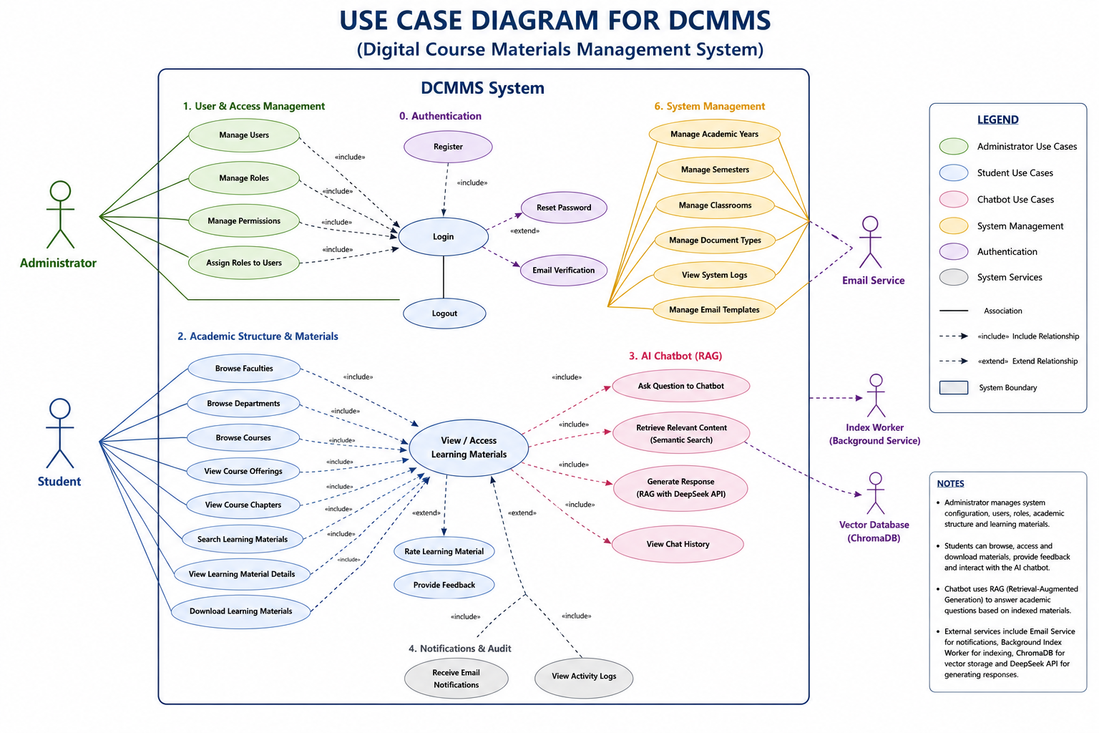
Figure 3. 2: Use Case Diagram for DCMMS

3.8.2 Activity Diagram
The Activity Diagram illustrates the operational workflow of the Digital Class Materials Management System (DCMMS) by representing the sequence of activities performed by users and the system during the execution of core functionalities. It provides a graphical representation of the control flow, beginning with user authentication and continuing through the execution of role-specific operations, learning material management, and AI-powered academic assistance.
The workflow begins when a user accesses the system through the Next.js frontend and submits valid authentication credentials. The request is forwarded to the Flask backend API, where the credentials are validated against the PostgreSQL database. After successful authentication, the system applies Role-Based Access Control (RBAC) to determine the user's assigned permissions and redirects the user to the appropriate dashboard based on the assigned role.
The Administrator is responsible for managing users, roles, permissions, academic structures, and learning materials. When educational materials are uploaded or updated, the system stores the file and its metadata, creates an indexing task, and automatically initiates the background indexing process. The indexing worker extracts document content, generates vector embeddings using the BAAI/bge-small-en-v1.5 embedding model, stores the embeddings in ChromaDB, and updates the indexing status in PostgreSQL. This process ensures that newly uploaded learning materials are immediately available for semantic retrieval by the AI-powered chatbot.
Students are authorized to browse available courses, access and download learning materials, update their profile information, submit feedback on learning materials, and interact with the AI-powered Retrieval-Augmented Generation (RAG) chatbot. When a student submits an academic question, the system converts the query into vector embeddings, retrieves the most relevant document chunks from ChromaDB using semantic similarity search, and forwards the retrieved context together with the user's question to the DeepSeek API. The generated response is returned to the backend, stored in the chatbot conversation history, and displayed to the student through the frontend interface.
The system also performs supporting activities such as recording user actions for auditing purposes, managing chatbot indexing jobs, maintaining conversation history, and sending system-generated email notifications for user registration, password recovery, and other account-related events.
Overall, the Activity Diagram provides a comprehensive representation of the operational workflow of DCMMS, illustrating the interaction between users, the frontend application, backend services, relational database, background indexing pipeline, vector database, and AI-powered chatbot. It demonstrates how secure authentication, academic resource management, Retrieval-Augmented Generation (RAG), and intelligent academic assistance are integrated into a unified system.

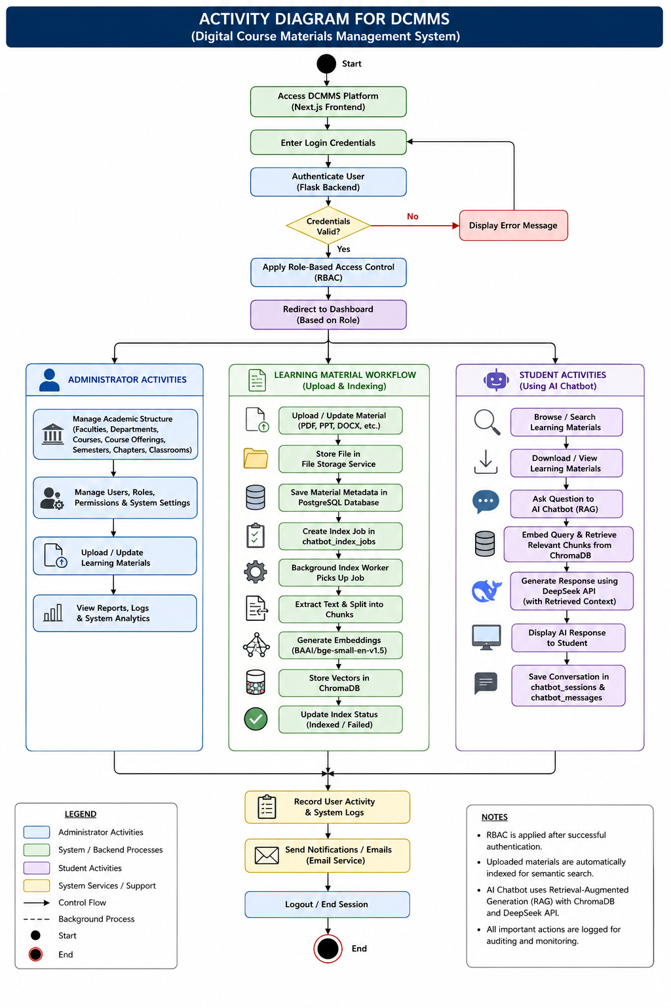
Figure 3. 3:Activity Diagram for DCMMS

3.8.3 Sequence Diagram
The Sequence Diagram illustrates the chronological exchange of messages among the major components of the Digital Class Materials Management System (DCMMS) during the execution of key system operations. It demonstrates how requests are exchanged between the Student or Administrator, the Next.js frontend, the Flask backend API, the PostgreSQL database, the file storage service, the background indexing worker, ChromaDB, the BAAI/bge-small-en-v1.5 embedding model, the DeepSeek API, and the email service to accomplish different system functions.
The interaction begins when a user submits authentication credentials through the Next.js frontend. The request is forwarded to the Flask backend, which validates the credentials against the PostgreSQL database. Upon successful authentication, the backend returns the user's role and grants access to the appropriate dashboard according to the assigned permissions. After authentication, users may perform authorized operations such as managing academic structures, uploading learning materials, browsing and downloading educational resources, interacting with the AI-powered chatbot, or administering system data, depending on their assigned role.
When an administrator uploads or updates learning materials, the Flask backend stores the material metadata in the PostgreSQL database and saves the uploaded file in the file storage location. The system then creates an indexing job in the chatbot_index_jobs table, which is processed asynchronously by the background indexing worker. The worker extracts text from the uploaded document, divides the content into chunks, generates vector embeddings using the BAAI/bge-small-en-v1.5 embedding model, stores the embeddings in ChromaDB, and updates the indexing status in PostgreSQL. This process ensures that newly uploaded materials become available for semantic retrieval by the chatbot.
When a student submits a question to the AI-powered chatbot, the frontend forwards the request to the Flask backend. The backend converts the query into a vector representation using the same embedding model and performs a similarity search against ChromaDB to retrieve the most relevant document chunks. The retrieved context is then combined with the user's query and forwarded to the DeepSeek API, which generates a context-aware response based solely on the retrieved academic materials. The generated response is returned to the backend, stored as part of the chatbot conversation history in PostgreSQL, and finally displayed to the user through the frontend interface.
The sequence diagram also illustrates interactions with supporting services. During user registration or password recovery, the backend communicates with the email service to send verification emails, temporary passwords, or system notifications. Similarly, all uploaded materials, chatbot conversations, indexing jobs, and user activities are persistently stored within PostgreSQL, ensuring data integrity and system traceability.
Overall, the Sequence Diagram provides a comprehensive representation of the communication flow among the software components of DCMMS. It demonstrates how the frontend, backend, relational database, file storage service, AI indexing pipeline, vector database, embedding model, DeepSeek API, and email service cooperate to support secure authentication, academic material management, Retrieval-Augmented Generation (RAG), and intelligent academic assistance

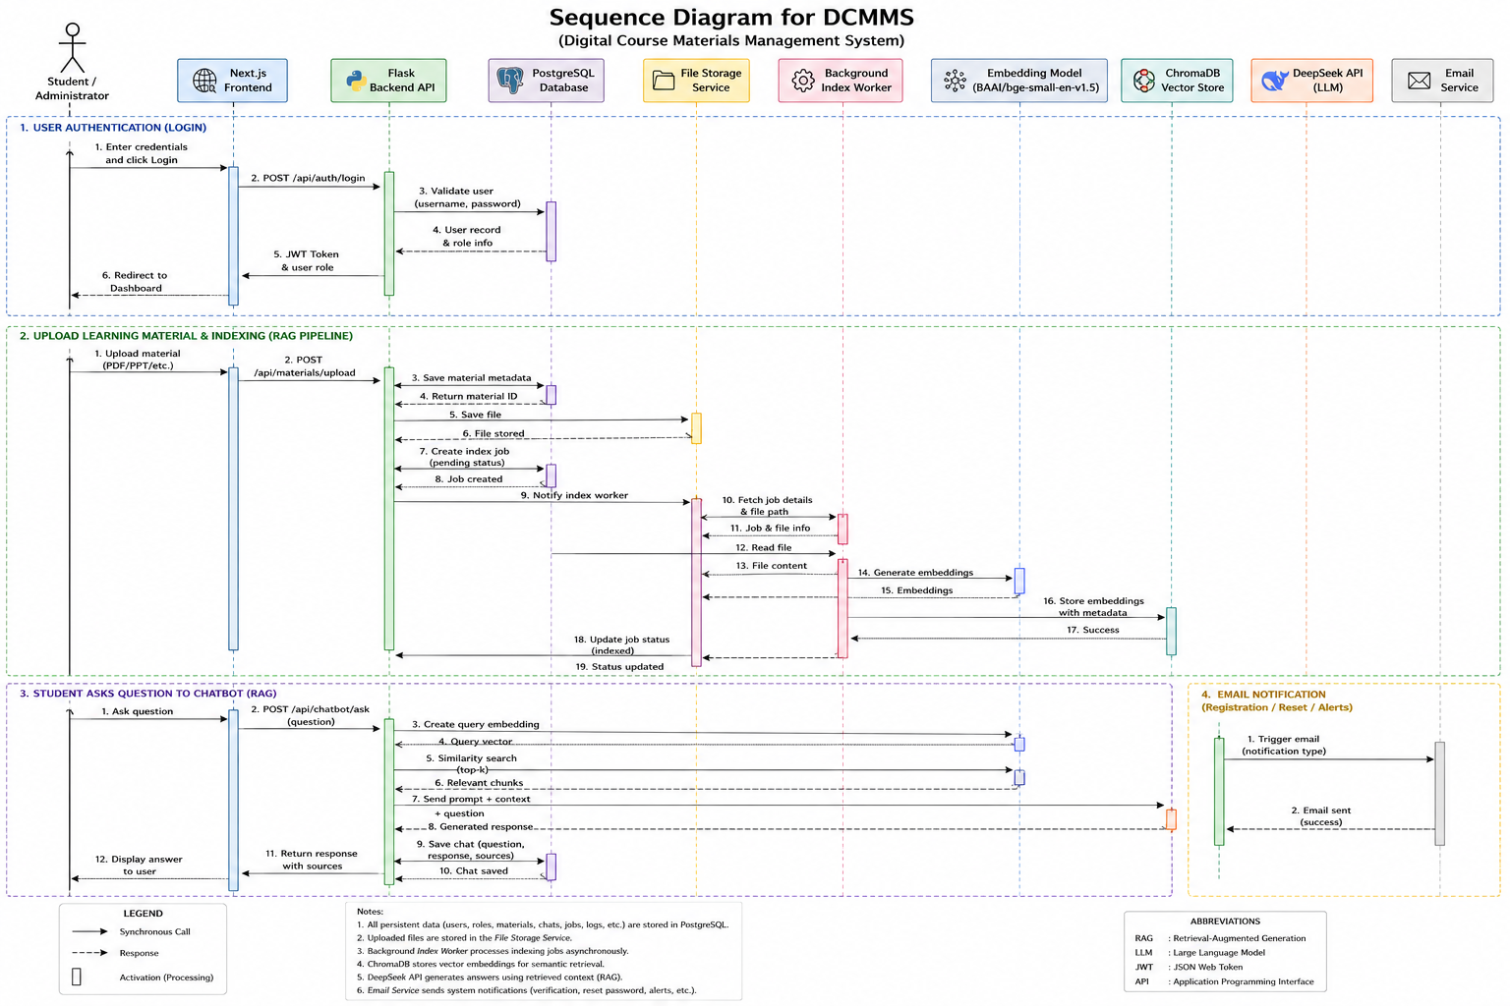
Figure 3. 4: Sequence Diagram for DCMMS

3.9 DATABASE DESIGN
The database design of the proposed system is based on the relational database model to ensure data integrity, consistency, scalability, and efficient data retrieval. The database schema is structured to support the major functional components of the Digital Class Materials Management System (DCMMS), including user and access management, academic structure management, learning material management, AI-powered chatbot services, and system administration. Furthermore, the database incorporates Role-Based Access Control (RBAC) to ensure secure authorization and controlled access to system resources based on user roles.

3.9.1 Database Tables
1. User and Access Control
This module manages user authentication, authorization, and access control within the system. It implements a Role-Based Access Control (RBAC) mechanism that assigns permissions according to user roles.
• users
The users table stores core user information including usernames, email addresses, encrypted passwords, account status, and company association. It serves as the primary entity for user authentication and identity management.
• roles
The roles table defines user roles such as Administrator and Student. Each role determines the permissions and level of access assigned to users.
• permissions
The permissions table defines individual system operations that may be assigned to roles, including user management, academic management, chatbot access, and system administration.
• user_roles
The user_roles table establishes a many-to-many relationship between users and roles, allowing users to be assigned one or more roles.
• role_permissions
The role_permissions table associates permissions with roles, thereby defining the actions that each role is authorized to perform.
• user_affiliations
The user_affiliations table stores organizational affiliations of users, including faculty and department associations, to support institutional organization and access control.
2. Profiles
The Profiles module extends the user account by maintaining detailed academic and staff information.
• student_profiles
The student_profiles table stores student-specific information such as registration number, academic program, level of study, contact information, and other academic details.
• staff_profiles
The staff_profiles table stores staff-related information including employee ID, designation, qualifications, department affiliation, office location, and contact details.
3. Academic Structure
This module represents the institutional academic hierarchy and organizes academic programs and course delivery.
• edu_faculties
Stores information about faculties representing the highest academic divisions within the institution.
• edu_departments
Stores academic departments associated with each faculty.
• edu_courses
Stores course information including course code, course title, description, and credit hours.
• edu_course_offerings
Represents course offerings for specific academic years and semesters by linking courses with classrooms and scheduling information.
• edu_classrooms
Stores information about physical and virtual classrooms used for course delivery.
• edu_academic_years
Defines academic years available within the institution.
• edu_semesters
Defines semesters associated with each academic year.
• edu_course_chapters
Stores structured chapters or topics belonging to each course to facilitate organized learning material management.
4. Learning Materials
This module manages educational resources, learner interactions, and student feedback.
• edu_materials
Stores digital learning resources including lecture notes, presentations, assignments, PDF documents, videos, and other educational materials.
• doc_types
Defines supported document categories such as PDF, DOCX, PPTX, images, videos, and other file formats.
• edu_material_interactions
Records student interactions with learning materials, including viewing, downloading, and other engagement activities for monitoring resource usage and generating learning analytics.
• edu_material_feedback
The edu_material_feedback table stores feedback submitted by students regarding learning materials, including comments, ratings, and submission timestamps. The information supports administrators in evaluating the quality and usefulness of educational resources and facilitates continuous improvement of learning materials.
5. AI Chatbot Module
This module supports the AI-powered Retrieval-Augmented Generation (RAG) chatbot by maintaining chatbot conversations and document indexing information.
• chatbot_sessions
Stores chatbot conversation sessions for individual users and maintains conversation history.
• chatbot_messages
Stores user questions and chatbot-generated responses together with timestamps and session references.
• chatbot_material_indexes
Stores indexing metadata generated for educational materials. These indexes support semantic retrieval of learning materials through the Retrieval-Augmented Generation (RAG) pipeline.
• chatbot_index_jobs
Stores indexing jobs created whenever educational materials are uploaded, updated, or deleted. The table tracks processing status, progress, retry attempts, and timestamps to support asynchronous background indexing.
6. System Management
This module supports backend administration, auditing, notifications, organizational management, database maintenance, and automatic code generation.
• actions
Maintains audit logs of significant system events including user authentication, uploads, downloads, administrative activities, and data modifications.
• email_outbox
Stores outgoing emails including password recovery messages, account verification emails, notifications, and other system-generated communications before delivery.
• notification_batches
The notification_batches table stores notification batch records created when the system distributes announcements or notifications to multiple recipients. It maintains batch metadata such as notification type, creation time, processing status, and delivery statistics, enabling efficient bulk notification processing and monitoring.
• push_outbox
The push_outbox table stores outgoing push notification messages awaiting delivery to users' devices. It maintains message content, recipient information, delivery status, retry attempts, scheduling information, and timestamps to support reliable asynchronous push notification delivery.
• user_device_tokens
The user_device_tokens table stores device registration tokens associated with authenticated users. These tokens enable the system to send push notifications to users' registered mobile devices while supporting multiple devices per user and secure token management.
• user_notifications
The user_notifications table stores notifications delivered to individual users. It records notification content, notification type, read or unread status, delivery timestamps, and related system references, allowing users to review notification history and enabling the system to track notification delivery and user acknowledgement.
• companies
The companies table represents the institution using the system. Although the schema supports future multi-tenant deployment by allowing multiple institutions to share a single platform, multi-tenancy is not implemented or evaluated within the scope of this study. The current implementation supports only the Department of Information Technology at Jamhuriya University.
• code_types
Defines configurable code categories used throughout the system, including student registration numbers, employee IDs, course codes, and other automatically generated identifiers.
• code_counters
Maintains sequential counters for each code type to ensure the automatic generation of unique identifiers while preventing duplication.
• alembic_version
The alembic_version table is automatically created and maintained by Alembic to record the current database schema version. It supports database migration management and schema version control throughout the software development lifecycle. This table is intended for internal system maintenance and is not directly accessed by end users.

3.9.2 Entity Relationship (ER) Diagram
The Entity Relationship (ER) Diagram presents the logical structure of the Digital Class Materials Management System (DCMMS) database by illustrating the entities, their attributes, and the relationships among them. It provides a comprehensive representation of the relational database schema, demonstrating how data are organized to support the functional requirements of the system while maintaining referential integrity through primary key and foreign key relationships.
The database is organized into six major functional modules: User and Access Control, Profiles, Academic Structure, Learning Materials, AI Chatbot, and System Management. The User and Access Control module implements Role-Based Access Control (RBAC) through the relationships among users, roles, permissions, user-role assignments, role-permission mappings, and organizational affiliations. The Profiles module extends user information by maintaining separate student and staff profile records associated with registered users.
The Academic Structure module models the institutional hierarchy by defining faculties, departments, courses, course offerings, classrooms, academic years, semesters, and course chapters. The Learning Materials module manages educational resources, document classifications, student interactions, and learning material feedback, enabling efficient organization, monitoring, and continuous improvement of digital learning resources.
The AI Chatbot module supports the Retrieval-Augmented Generation (RAG) framework by maintaining chatbot sessions, conversation history, material indexing metadata, and indexing jobs. These entities support the background indexing process, enabling educational materials to be semantically indexed in the vector database and retrieved efficiently during chatbot interactions. The System Management module supports auditing, email notifications, organizational management, and automatic code generation through dedicated system tables.
Overall, the ER Diagram illustrates the relationships among the twenty-nine application database tables, while the system also includes one migration table (alembic_version) used internally by Alembic for database schema version control. Together, these tables provide a robust relational database structure that supports secure user management, academic administration, digital learning resource management, Retrieval-Augmented Generation (RAG), intelligent academic assistance, and efficient system administration while ensuring data consistency and referential integrity.

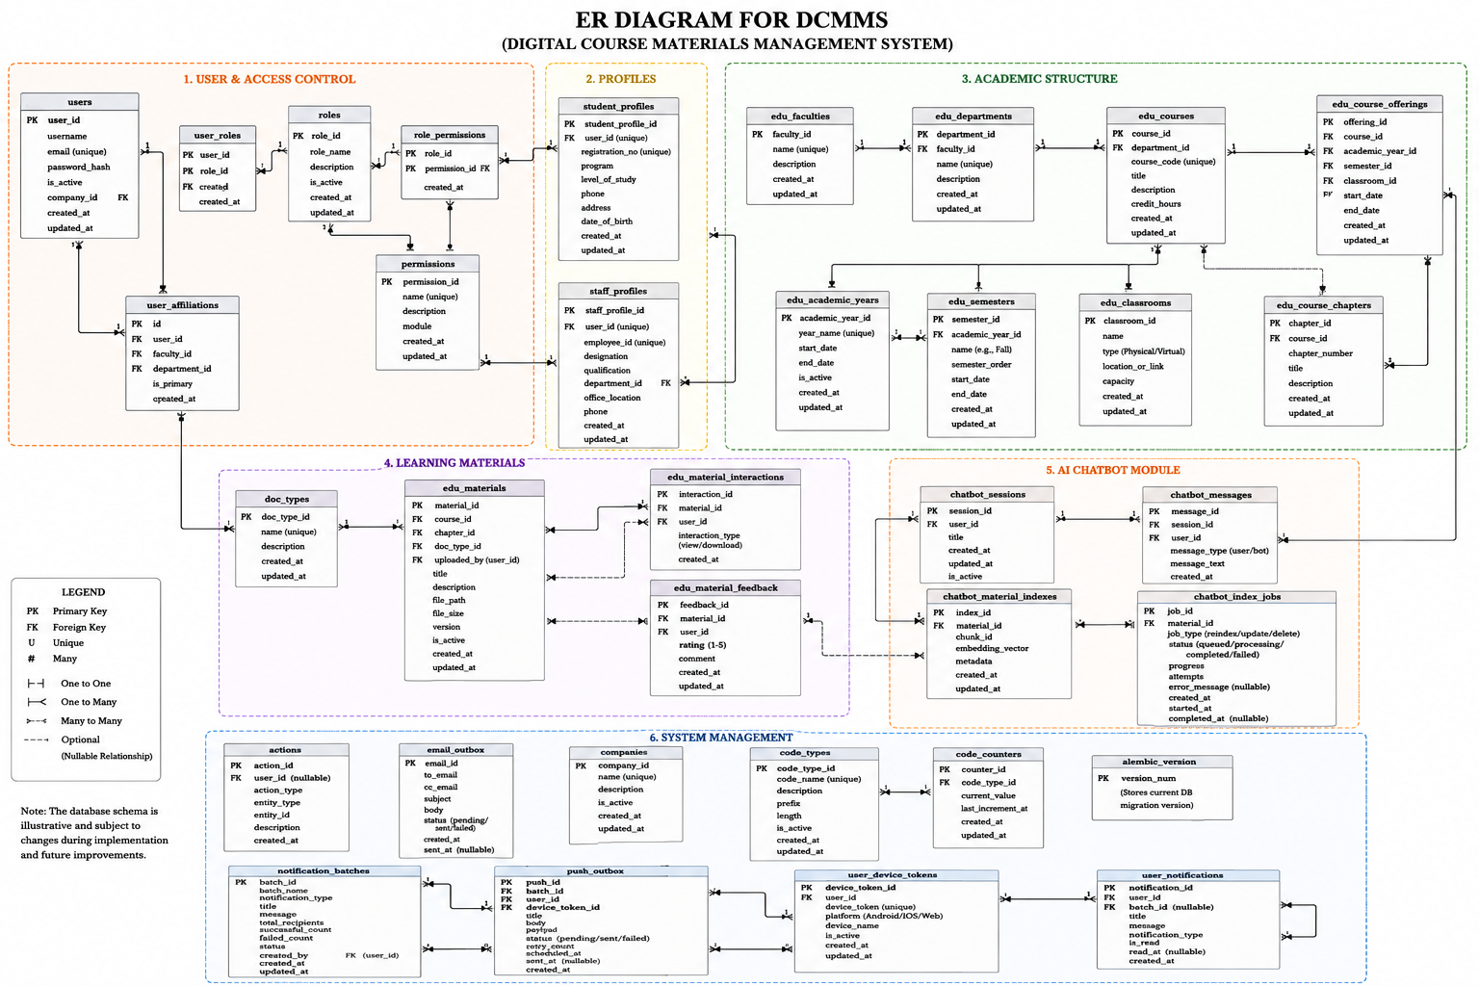
Figure 3. 5: ER Diagram for DCMMS

3.9.3 Role-Based Access Control (RBAC)
The system implements a robust RBAC mechanism to ensure secure access to resources.
1. Process:
- User logs in
- Role assigned
- Permissions checked
- Access granted/denied
2. Roles and Privileges:
1. Admin: Full system control including user management, academic structure management, material management, and system administration.
2.Student: Access to view courses, search materials, download resources, and interact with the AI chatbot.
3.9.4 Database Justification
The database schema applies normalization principles to reduce redundancy and maintain referential integrity. Query performance is supported through the following indexing strategy: every foreign key column is explicitly indexed, since PostgreSQL does not create these automatically this includes edu_materials. offering_id, edu_materials.chapter_id, edu_materials.uploaded_by, chatbot_messages.session_id, chatbot_material_indexes.material_id, and user_affiliations.user_id, among others. In addition, columns used in frequent filtering or lookup operations are indexed independently of their key role, includingedu_materials.is_active, chatbot_index_jobs. status, and users.email (which also carries a unique constraint).
The schema's relationships follow clear cardinalities that reflect real academic structure: a faculty has many departments, a department has many courses, and a course has many offerings across academic years and semesters (each 1:N). A course offering has many materials, and a material may be referenced by many chatbot material indexes as it is re-chunked on update (also 1:N). Users and roles form a many-to-many relationship through user_roles, as do roles and permissions through role_permissions, allowing a single user to hold multiple roles without duplicating permission data.
Security is enforced at the schema level: users.password_hash never stores passwords in plaintext, users.email and users.username carry unique constraints to prevent duplicate accounts, and access to system-maintenance tables such as alembic_version is restricted from direct end-user interaction. Together, normalization, targeted indexing, and explicit constraint enforcement ensure the schema remains both performant under expected query load and structurally sound as the system scales.

3.10 RAG Chatbot Design
The system integrates a Retrieval-Augmented Generation (RAG) chatbot that provides natural-language access to the department's academic materials. The chatbot is restricted to generating responses grounded in indexed content, and its architecture combines a locally hosted embedding model, a local vector database (ChromaDB), a background indexing worker, and the DeepSeek API for response generation.

3.10.1 System Components
Embedding model the system uses BAAI/bge-small-en-v1.5, a compact pre-trained sentence embedding model, to convert text into vector representations. The model is downloaded once per machine using a one-time setup script (scripts/download_embedding_model.py), stored at backend/instance/embedding_models/. Without this step, the indexing worker fails with the error Embedding model not found. Run: python scripts/download_embedding_model.py. One downloaded model instance serves the entire application and is excluded from version control due to file size.
ChromaDB a local vector database (instance/chroma_db/) storing vector embeddings for each indexed material chunk and supporting similarity search at query time. Its contents grow incrementally as materials are indexed, and it is likewise excluded from version control.
PostgreSQL stores material metadata (title, course, uploader) and tracks each material's indexing state via index_status and chunk_count fields.
DeepSeek API the generative language model producing the final natural-language output. This is the only pipeline component requiring network connectivity; the embedding model and ChromaDB operate entirely on local disk once set up.

3.10.2 Indexing Pipeline (Background Worker)
Material indexing runs asynchronously via scripts/chatbot_index_worker.py, a dedicated background process running continuously in a separate terminal from the main web server, analogous to an email-queue worker. For newly uploaded materials, an indexing job is created automatically; no manual step is required beyond ensuring the worker is running. For each job:
Text extraction text is extracted from the uploaded PDF or PPTX.
Chunking and embedding extracted text is divided into chunks, each converted into a vector using BAAI/bge-small-en-v1.5.
Vector storage vectors are saved into ChromaDB, tagged with the corresponding material identifier.
Status updates the material's PostgreSQL record is updated with index_status = indexed and chunk_count = N.

3.10.3 Reindexing of Pre-Existing Materials
Since the indexing pipeline was introduced after the system was already in use, scripts/reindex_existing_materials.py is provided as a one-time script to index materials uploaded prior to the chatbot feature. It is not required for new uploads, which are indexed automatically by the background worker.

3.10.4 Query Pipeline and Generation Modes
When a user interacts with the chatbot, the query is embedded using the same embedding model, ChromaDB is searched for the most similar chunks (optionally filtered by material), and the retrieved chunks are passed to DeepSeek for generation. The system supports five distinct generation modes, each governed by a shared set of grounding rules: each built around a shared set of strict grounding rules:
Answer only from the provided material context.
Do not use outside knowledge.
If the material does not contain the answer, say the material does not cover it.
Conversational Q&A answers a student's question using retrieved context and prior chat history, supporting multi-turn conversation grounded in a specific material.
Summarization produces a structured summary under fixed headings (Overview, Key Concepts, Key Takeaways).
- Quiz generation generates a ten-question multiple-choice quiz with an appended answer key. Study-plan generation produces a structured weekly study plan based on the topics and academic materials selected by the student. The generated plan organizes the relevant material into manageable study activities without introducing content outside the uploaded academic resources.
- Q&A set generation generates ten open-ended study questions with full model-generated answers as a self-study aid.
All modes additionally instruct the model to format output in Markdown with short paragraphs, and to cite the relevant chapter or topic name inline where helpful.

3.10.5 Offline/Online Boundary
Indexing and retrieval operate entirely on local infrastructure: once the embedding model is downloaded, both embedding generation and ChromaDB similarity search require no internet connection. The only point requiring external connectivity is the DeepSeek API call for response generation. Indexing throughput is therefore not constrained by external API availability, while chatbot response availability remains dependent on DeepSeek API access.

3.10.6 Citation and Traceability
The current prompt design requests inline citation of the relevant chapter or topic name within the generated answer text. This is a soft, model-dependent form of traceability: because it is produced as free text rather than derived directly from retrieval metadata, its presence and accuracy are not guaranteed for every response.
This differs from structural traceability, in which the source material_id, title, and page/chunk metadata already available from the ChromaDB retrieval step are attached programmatically to the API response, independent of whether the model mentions them in generated text. Structural traceability is more reliable, since it does not depend on the language model consistently citing its source.
The present implementation relies on inline citation only. Extending this to structural traceability returning retrieved chunks' source metadata alongside the generated answer regardless of the model's own text is recommended as a refinement, since verifiable sourcing is a core justification for using RAG rather than a plain chatbot.

3.10.7 Hallucination Control
Hallucination risk is addressed through the shared strict grounding rules applied to every generation mode, instructing DeepSeek to answer only from retrieved context and to explicitly decline when that context is insufficient, rather than drawing on its own general-purpose training knowledge.

3.10.8 Functional Validation of the RAG Chatbot

The RAG chatbot was evaluated through predefined internal test queries based on the uploaded academic materials. The evaluation examined whether the chatbot retrieved relevant material content and returned a context-relevant response. The test was recorded as passed when the response was related to the selected material and did not introduce information outside the retrieved context.

3.11 Development Methodology
The system was developed using the Object-Oriented Analysis and Design Methodology (OOADM), applied iteratively across four phases. During requirements analysis, the project problem and functional and non-functional requirements were identified. During system design, use-case, activity, sequence, database, and architecture models were prepared. During implementation, the identified system entities and processes were translated into Flask backend modules, Next.js interfaces, React Native components, and PostgreSQL data structures. During evaluation, predefined functional, mobile, API, compatibility, and selected security test cases were executed. When implementation revealed necessary design changes, the relevant models and database structures were revised accordingly.

3.12 Internal System Evaluation Design
The system was evaluated through internal technical testing conducted by the development team using predefined test cases. The evaluation examined functional correctness, mobile application behavior, device compatibility, API responses, authentication, authorization, input validation, and selected security controls

3.13 Testing Categories
The evaluation covered five categories: functional testing, mobile unit and integration testing, device compatibility testing, API testing, and security testing. Each test case defined the action performed, expected outcome, actual outcome, and final pass or fail status.

3.14 Evaluation Procedure
The development team executed each predefined test case in a controlled development environment. The actual system response was compared with the expected result. A test was marked as passed when the actual outcome matched the expected outcome and failed when the expected behavior was not achieved.

3.15 Evidence Collection
Testing evidence consisted of recorded test-case results, system responses, interface observations, API status codes, and screenshots of implemented system functions.

3.16 Data Analysis Method
The results were analyzed using test-case pass rates. The pass rate was calculated by dividing the number of passed test cases by the total number of executed test cases and multiplying the result by 100. Results were summarized separately for functional, mobile, compatibility, API, and security testing.

CHAPTER IV: IMPLEMENTATION AND RESULTS

4.1 Introduction
This chapter presents the implementation, testing, and evaluation of the Just Click Digital Class Materials Management System (DCMMS). Building upon the system design and architectural decisions established in Chapter III, this section provides a rigorous account of how each component was realized in practice, the testing protocols applied to validate correct behavior, and the outcomes observed across all evaluation dimensions. The primary objective of the implementation phase is to demonstrate, through empirical evidence, that the developed system functions correctly, satisfies its stated functional and non-functional requirements, and constitutes a usable, secure, and reliable platform for academic resource management within the Somali higher-education context.
The chapter is structured into four principal sections: (1) Web System Implementation and Testing, covering the public-facing interfaces and the administrator panel; (2) Mobile Application Implementation and Testing, documenting the React Native companion application; (3) Backend and API Development and Testing, detailing the Flask-based RESTful service layer; and (4) Security Implementation and Testing, evaluating the multi-layered security architecture. All major system interfaces are illustrated through annotated screenshots, accompanied by structured test cases that verify system behavior under both normal operational conditions and defined boundary scenarios.

4.2 Snapshots of the System
The subsections that follow present annotated screenshots of the Just Click system, covering its primary interfaces and feature set. These screenshots serve as evidence that the design specifications articulated in Chapter III were faithfully translated into a functional web-based platform. The interfaces are organized by user role and functional area, progressing from the public-facing landing page through to the authenticated interfaces for students and administrators.

4.2.1 Web System Implementation and Testing
The Just Click system is a fully web-based platform accessible through any standards-compliant web browser without the requirement for proprietary plugins or client-side installations. It serves two primary user roles Administrator and Student each provisioned with a tailored interface and a precisely bounded permission set, as formalized in the Role-Based Access Control (RBAC) model described in Chapter III. The web system was implemented using Next.js as the frontend framework and Flask as the backend framework, with PostgreSQL serving as the relational database engine.

4.2.1.1 Landing Page
Figure 4.1 shows the landing page of Just Click, which constitutes the public entry point to the platform. The page communicates the system's value proposition All your course materials with AI help and provides clearly delineated pathways to account creation and login. Three key platform capabilities are highlighted at the hero level: Mobile-friendly access, Offline downloads, and Verified uploads. These three capabilities were deliberately selected based on the needs assessment conducted during the requirements elicitation phase (Chapter II), which identified limited device diversity, intermittent connectivity, and content authenticity as primary concerns for students and administrators in Mogadishu. The landing page is designed to be visually compelling, fully responsive, and to orient new users toward registration with minimal cognitive friction.
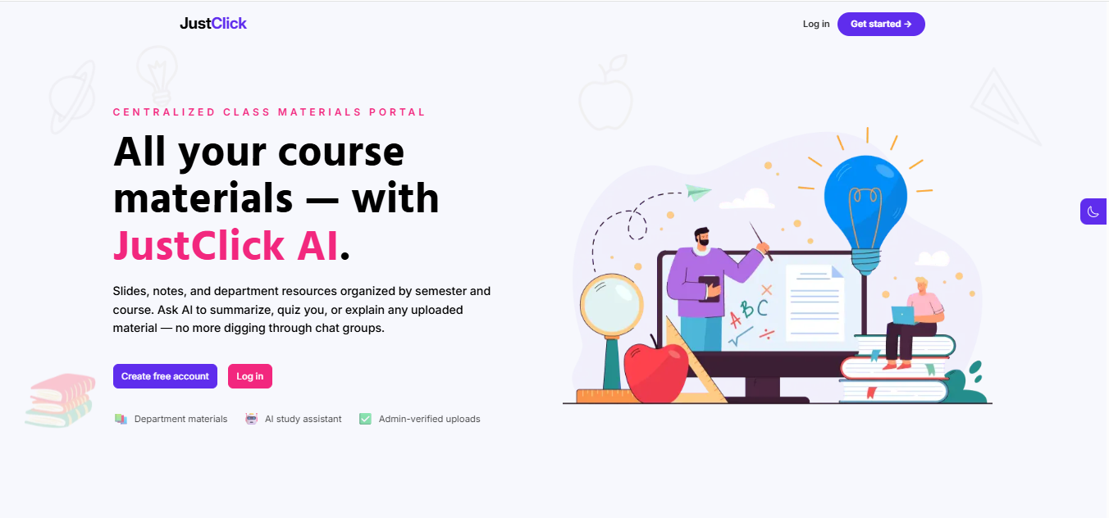
Figure 4. 1: Just Click Landing Page

4.2.1.2 Login / Authentication Interface
Figure 4.2 illustrates the Sign In interface, which serves as the authentication gateway for all registered users. The interface presents fields for Username and Password, a 'Remember me' persistence option, and a 'Forgot password?' recovery link. The design is intentionally minimal and task-focused, reducing cognitive load and streamlining the authentication process. Upon successful credential verification, the system evaluates the authenticated user's role claim embedded within the issued JSON Web Token (JWT) and executes a role-appropriate redirect: administrators are directed to the administrative dashboard, and students to the study materials browsing interface.

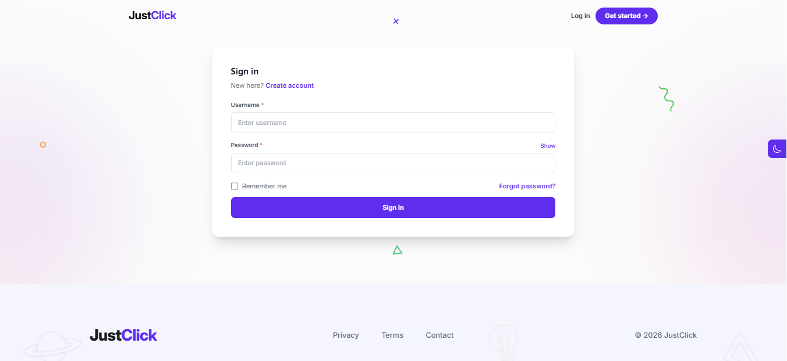
Figure 4. 2: User Authentication (Sign In) Interface

4.2.1.3 Admin Dashboard Overview
Figure 4.3 presents the Administrator Dashboard, which provides a consolidated operational overview of platform activity. Four primary metric cards are displayed at the dashboard apex: Total Users (4), Pending Approvals (4), Total Materials (5), and Material Analytics (21 total interactions). Below the metric cards, a User Growth chart renders monthly registration trends in a time-series format, enabling administrators to identify enrolment patterns and system adoption velocity. A Material Composition panel presents the distributional breakdown of uploaded file types, supporting resource planning decisions. The sidebar navigation provides structured access to Academic Management, Students, Staff, Onboarding Queue, and Profile Settings modules. This consolidated view equips administrators with the operational visibility necessary to govern the platform effectively, without requiring navigation across multiple discrete screens.
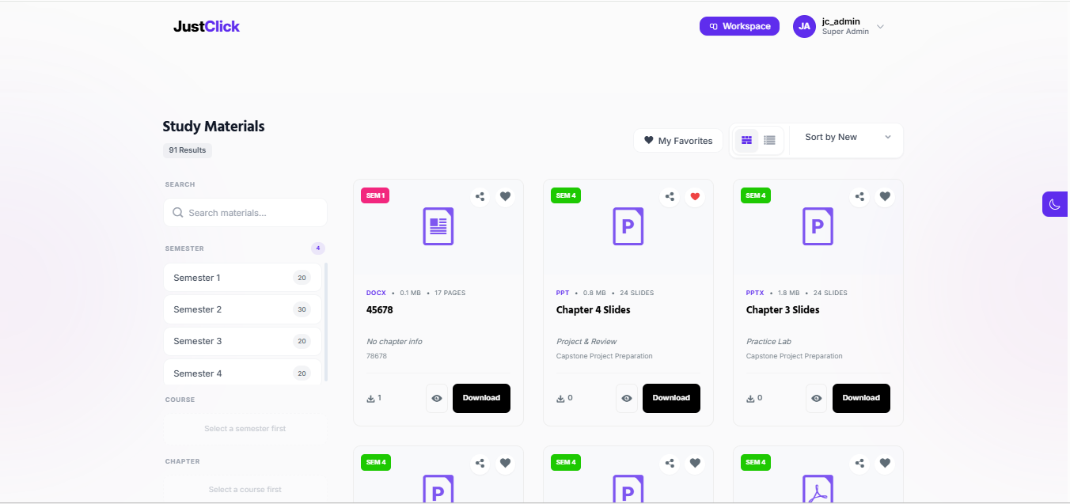
Figure 4. 3: Administrator Dashboard Operational Overview

4.2.1.4 Study Materials Browsing Interface
Figure 4.4 displays the Study Materials page, which constitutes the primary content discovery interface for both students and lecturing staff. Materials are presented in a responsive card-based grid layout; each card surfaces the material's file type (PPT), file size (e.g., 12.5 MB), slide count (e.g., 45 Slides), title, chapter, and associated course name. The left-hand navigation panel provides cascading filter controls by Semester and Course, enabling progressive narrowing of the material corpus. The current view returns four results. Users may toggle between grid and list views, apply sort criteria (newest first), and mark individual items as favorites for expedient future retrieval. Download affordances are prominently positioned on each card to minimize the action cost for the most common student interaction.

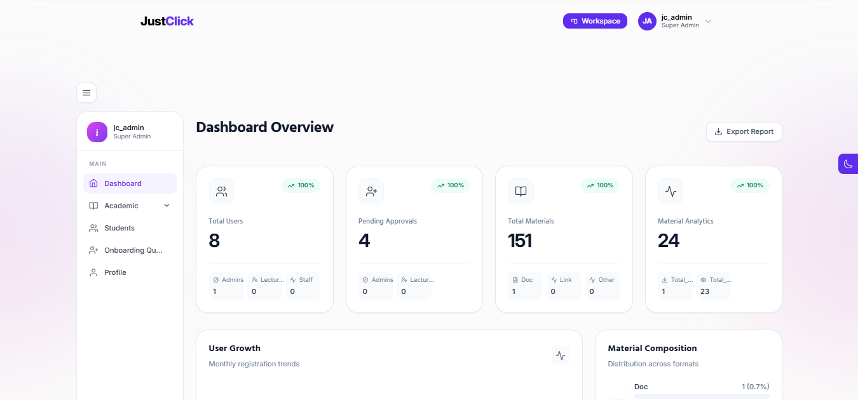
Figure 4. 4: Study Materials Browsing Interface Card Grid View

4.2.1.5 Material Detail Page Header
Figure 4.5 shows the upper portion of an individual material's detail page. The hero banner adopts the system's deep-purple branding identity and displays the material's course code (OS102), department (Software Engineering), semester (Semester 2), and enablement status (Enabled). The material is identified as a PowerPoint slides file titled 'Lecture 252', with a contextual subtitle identifying it as the Week 1 lecture in the relevant course sequence. This header section provides immediate contextual orientation, allowing users to confirm the material's academic provenance before proceeding to interact with its content.

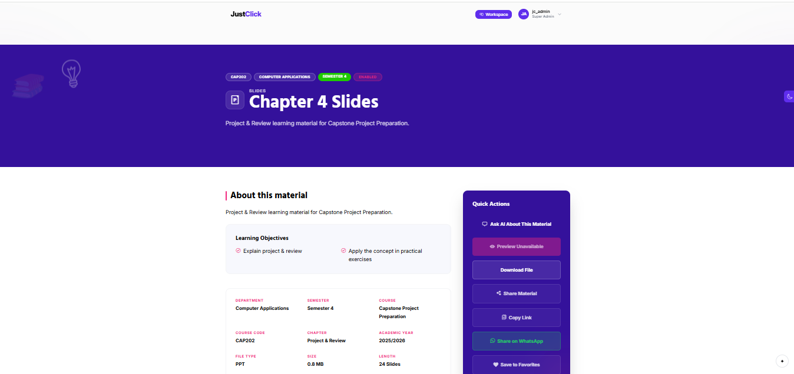
Figure 4. 5: Material Detail Page Hero Header Section

4.2.1.6 Material Detail Page About Section and Quick Actions
Figure 4.6 presents the lower portion of the material detail page. The left-hand panel, titled 'About this material', enumerates the material's Learning Objectives (Syntax and Variables) and a comprehensive structured metadata inventory: Department (Software Engineering), Semester (Semester 2), Course (Operating Systems Basics), Course Code (OS102), Chapter (Core Concepts), Academic Year (2025/2026), File Type (PPT), Size (12.5 MB), Length (45 Slides), creation date (5 April 2026), last updated (27 April 2026), and download count (4). The right-hand Quick Actions panel provides prominent, clearly labelled affordances for: Open Material, Download File, Share Material, Copy Link, Share on WhatsApp, and Save to Favorites. This two-column layout ensures that both detailed informational context and the most frequently required actions are simultaneously accessible without scrolling, reducing interaction cost for the most common usage patterns.
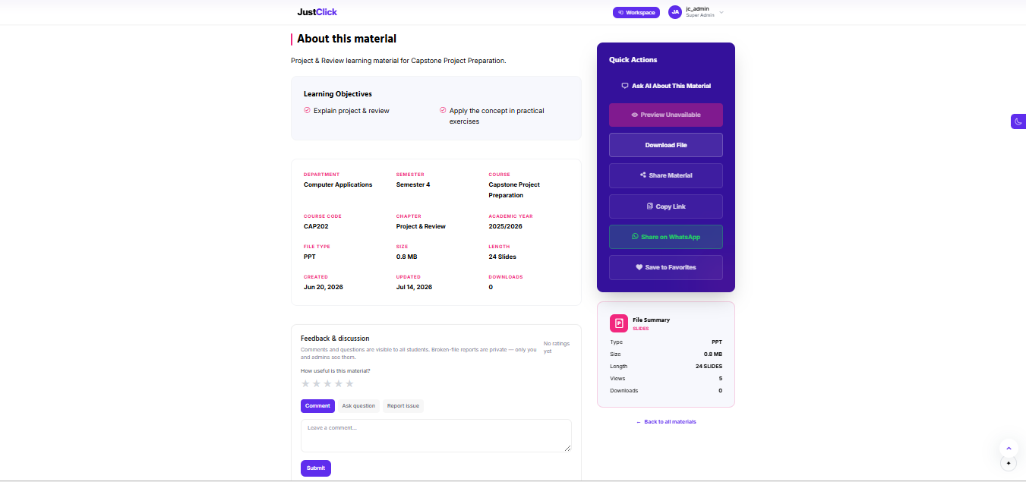
Figure 4. 6: Material Detail Page Metadata Panel and Quick Actions

4.2.1.7 AI-Powered Chatbot Interface (Just Click Chat)
Figure 4.7 shows the Just Click AI Chatbot interface, which implements the Retrieval-Augmented Generation (RAG) architecture described in Chapter III. Students may select a target semester and subject from dropdown menus and then submit natural-language queries regarding the content of uploaded course materials. The interface additionally provides four pre-built prompt shortcuts to lower the barrier to AI-assisted learning: Make quizzes from this subject, summarize my notes, give me important exam topics, and explain this chapter simply. The sidebar maintains a persistent log of prior chat sessions, supporting continuity across study sessions. This feature distinguishes Just Click from conventional document repositories by enabling intelligent, context-grounded academic dialogue rather than passive file retrieval alone. The RAG architecture ensures that the AI's responses are anchored to the institution's own uploaded materials, mitigating the hallucination risks associated with general-purpose language model deployments.
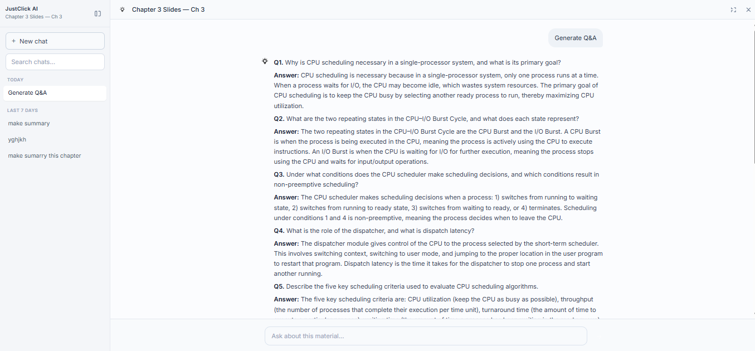
Figure 4. 7: Just Click AI Chatbot Interface RAG-Powered Academic Assistant

4.2.2 Mobile Application Implementation and Testing
In addition to the web-based platform, Just Click was developed as a companion mobile application targeting Android and iOS devices. The mobile application extends the core functionality of the DCMMS to students and staff operating in mobile-first contexts, reflecting the empirical reality that the majority of internet users in Somalia access digital services primarily through smartphones rather than desktop or laptop computers. The mobile application was implemented using React Native, a cross-platform framework that compiles a single JavaScript codebase to native binaries for both Android and iOS targets, thereby eliminating the need to maintain two separate codebases while preserving native-quality performance. The mobile client communicates exclusively with the same Flask RESTful API backend that serves the web system, ensuring full data consistency and unified security enforcement across both client surfaces.

4.2.2.1 Mobile Application Features
The mobile application replicates and appropriately adapts the core student-facing features of the web platform for a touch-first, mobile-optimized interaction paradigm. The following subsections describe each major screen with reference to annotated screenshots.
(a) Authentication Screen
Figure 4.8 shows the mobile Sign In screen. The interface presents Username and Password input fields, a 'Remember me' toggle for persistent session retention, a 'Forgot password?' recovery link, and placeholder affordances for future social sign-in options via Google and Apple. The design is intentionally minimal, eliminating non-essential visual elements to reduce cognitive load for both first-time and returning users. Upon successful authentication, the system validates the user's JWT, extracts the role claim, and routes the user to the appropriate home screen for their role.

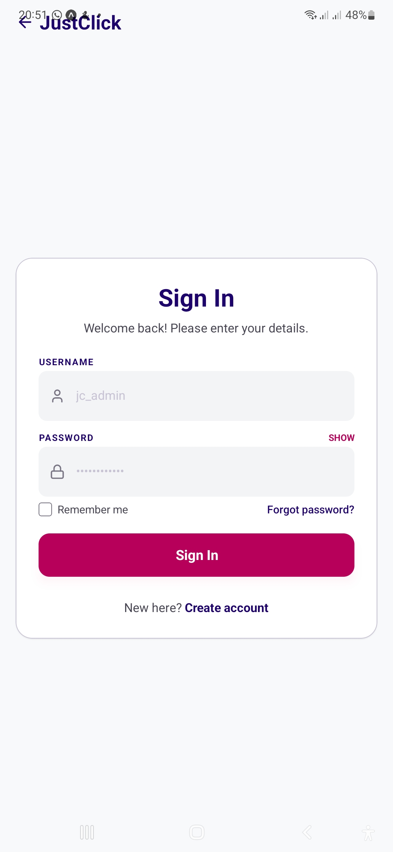
Figure 4. 8: Just Click Mobile Application Authentication (Sign In) Screen
(b) Landing / Home Screen
Figure 4.9 displays the mobile home screen, which greets authenticated students with the platform's value proposition: 'Study smarter with AI help.' The screen highlights three platform capabilities instant AI-powered explanations, personalized study paths, and automated summaries and provides quick-access navigation to all primary features. The interface adopts the platform's consistent deep-purple and pink branding, maintaining strong visual coherence with the web interface and reinforcing brand recognition across client surfaces.
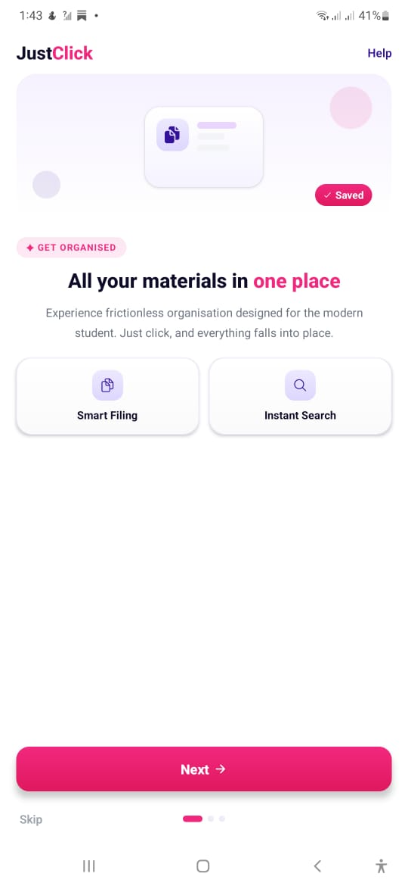
Figure 4. 9: Just Click Mobile Application Home / Landing Screen
(c) Study Materials Browsing Screen
Figure 4.10 presents the Study Materials screen on mobile, which mirrors the web browsing interface in a touch-optimized, single-column card layout appropriate for narrow viewports. Each material card displays the file type badge (PPT), material title, course name, file size (12.5 MB), slide count (45 Slides), and a prominently positioned Download button. Cascading filter controls for Semester, Course, and Chapter are accessible at the top of the screen. The current view presents materials including Lecture 252 and Lecture 202 from the Operating Systems Basics course. A persistent bottom navigation bar provides access to the Home, Sign In, and Downloads sections of the application.
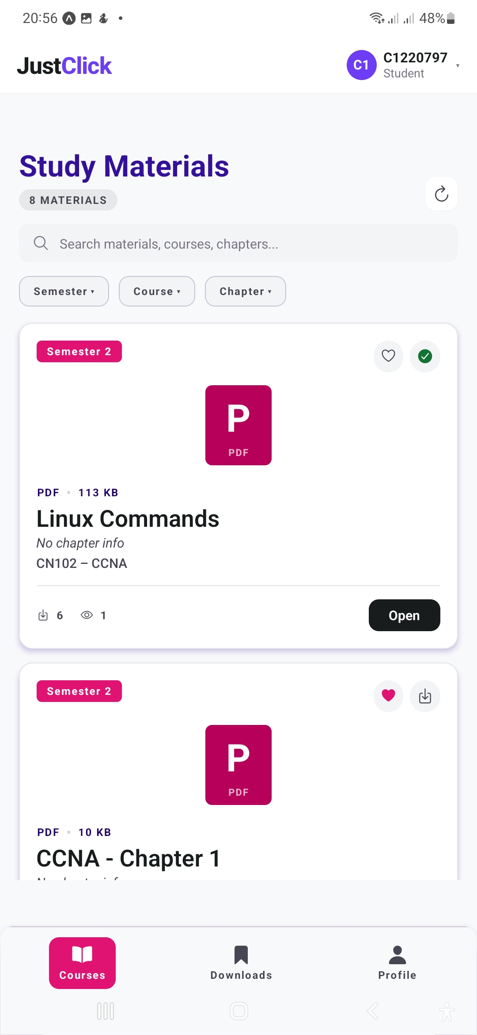
Figure 4. 10:Just Click Mobile Application Study Materials Browsing Screen
(d) AI Chatbot Screen
Figure 4.11 shows the mobile AI chatbot interface, which brings the RAG-powered academic assistant to the student's smartphone. The screen greets the authenticated student by name and presents an open prompt input field alongside four suggested prompt shortcuts: Summarize my uploaded notes, create a study plan for this week, download 10 past questions, and explain the hundred concurred simply. This prompt-shortcut pattern is particularly significant in the Somali educational context, where many students may be unfamiliar with open-ended AI interaction paradigms; by surfacing the most educationally productive query types as tappable affordances, the interface substantially reduces the usage barrier for students new to AI-assisted learning.
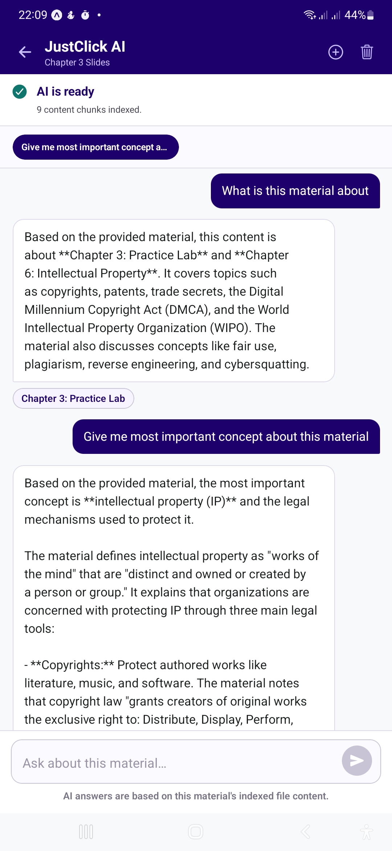
Figure 4. 11: Just Click Mobile Application AI Chatbot (RAG-Powered) Screen
(e) Material Detail Screen
Figure 4.12 illustrates the individual material detail screen for Lecture 252 (Operating Systems). The screen is organized into an 'About this material' descriptive section and a structured Details panel listing the Learning Objectives (OS and Variables), Faculty (Computer Science), Department (Software Engineering), Semester (Semester 2), Course (OS102), File Type (PPT), Size (12.5 MB), and slide count (45 Slides). Three primary action buttons Open Material, Download, and Share are anchored at the base of the screen via a persistent action bar, ensuring immediate accessibility regardless of scroll position.
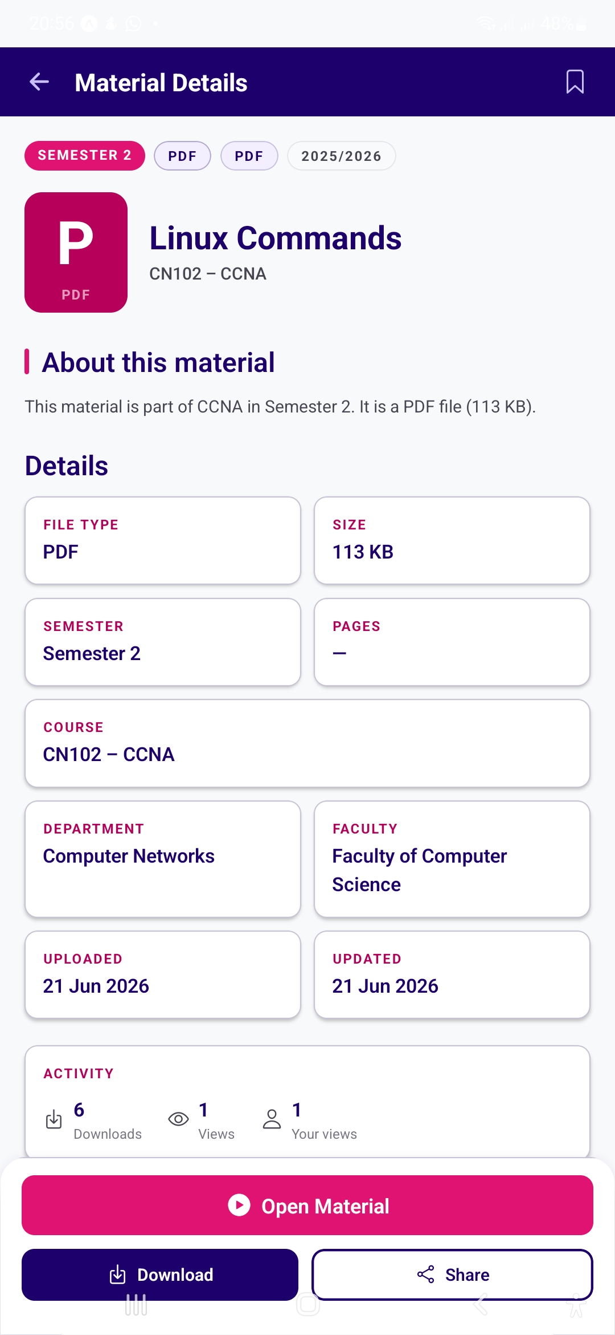
Figure 4. 12: Just Click Mobile Application Material Detail Screen
(f) Student Profile Screen
Figure 4.13 displays the Student Profile screen for the authenticated user Filastin Ahmed (SE Student). The screen is organized into three functional sections: Academic Overview, which presents summary metrics for materials accessed (24), interactions (125), and an academic engagement rating (3.2); Academic Profile, which displays the student's Faculty (Computer Science), Department (Software Engineering), and current Semester (Semester 2); and Account Settings, which provides access to Profile Settings, Notification Preferences, and Change Password. A Help and Legal section offer links to Support, Terms of Service, and Privacy Policy. A clearly labelled Log Out button is positioned at the screen base to enable unambiguous, accessible session termination.
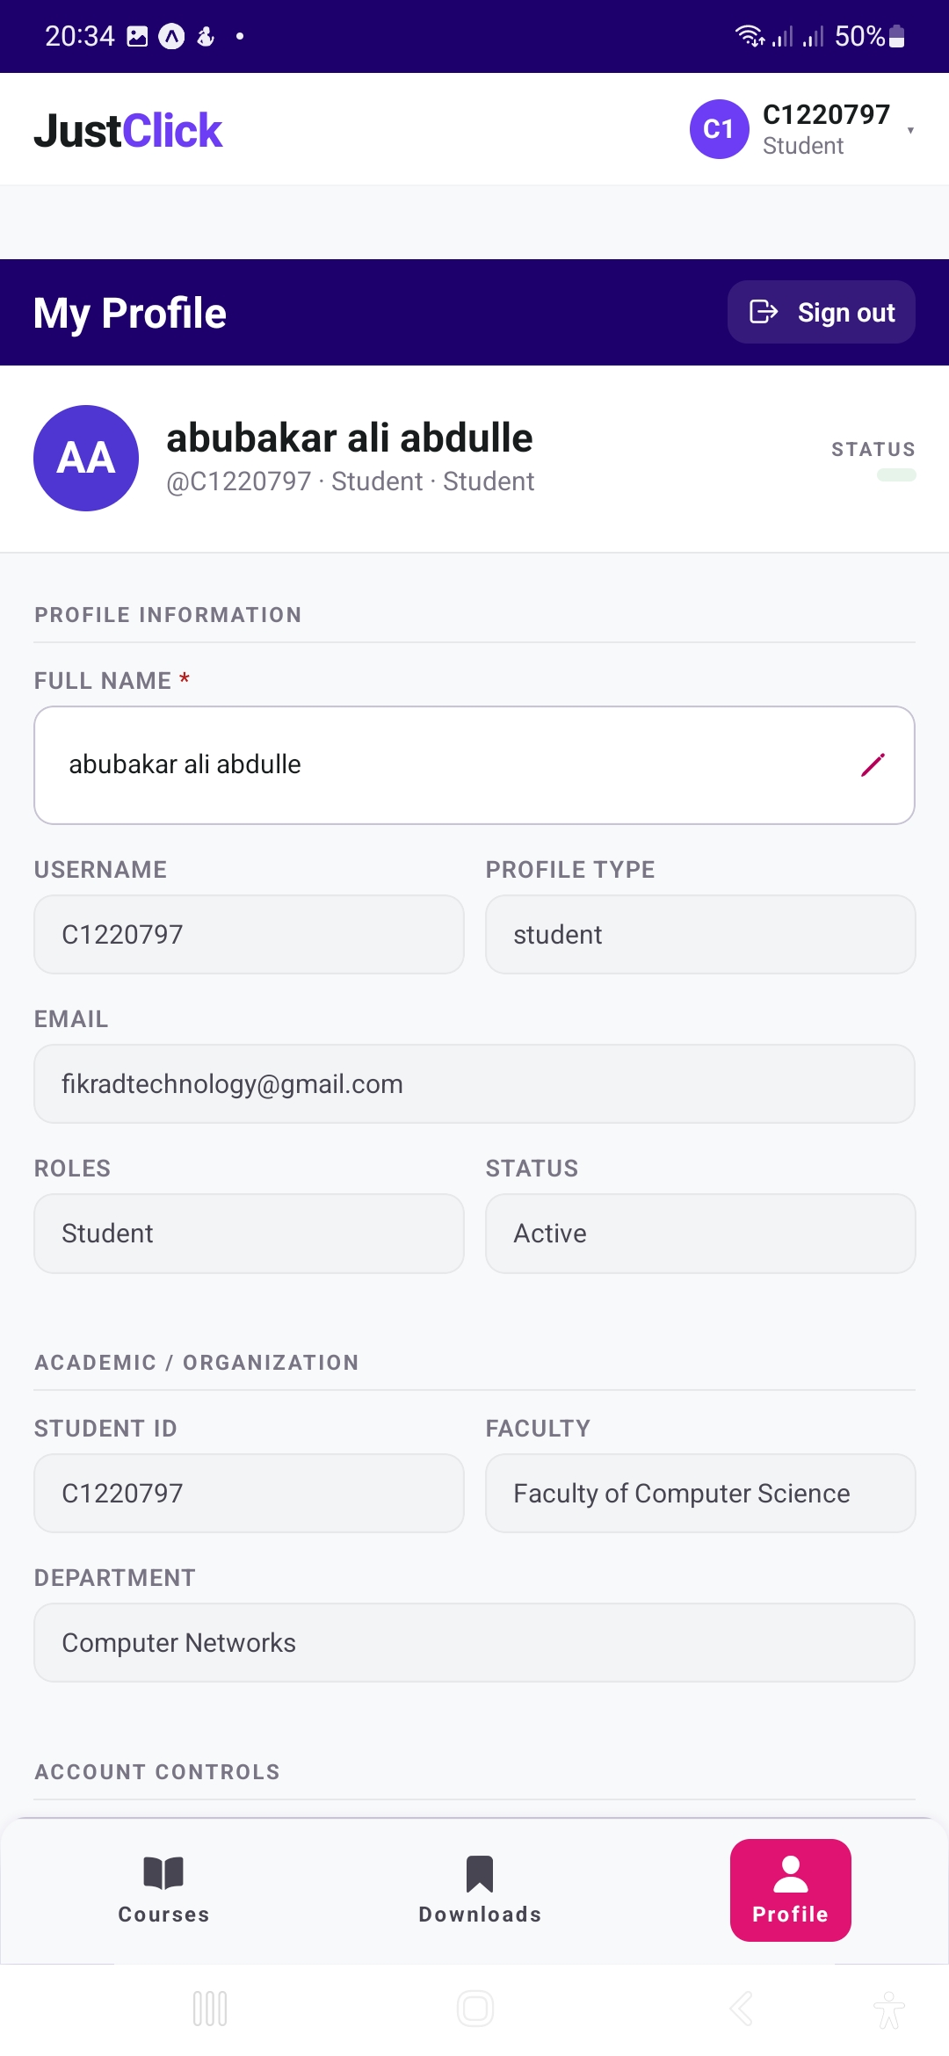
Figure 4. 13: Just Click Mobile Application Student Profile Screen

(G) Downloads Screen
Figure 4.14 presents the Downloads screen of the mobile application, which provides students with centralized access to study materials that have been downloaded for offline use. The interface adopts a clean, single-column card layout optimized for mobile devices, allowing users to efficiently manage and access saved learning resources.
Each download card displays essential information, including the file type (PDF), material title (Linux Commands), course code and name (CN102 – CCNA), file size (113 KB), and the date the material was saved. Additional usage statistics, such as the number of views and downloads, are displayed at the bottom of the card to provide students with quick reference information. Action buttons are provided to open the material offline, share the file, or remove it from the downloads list, enabling convenient management of locally stored resources.
At the top of the screen, a Saved indicator displays the total number of downloaded materials, while a Clear All option allows users to remove all saved files with a single action. An informational message reminds users that downloaded materials are available for offline viewing within the application. The screen also maintains a persistent bottom navigation bar, providing quick access to the Courses, Downloads, and Profile sections, ensuring consistent navigation throughout the mobile application.
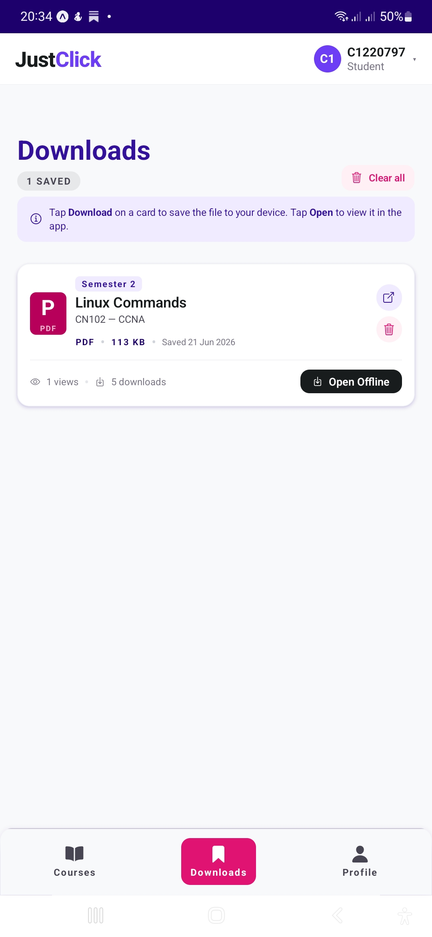
Figure 4.14: Mobile Downloads Screen

4.2.2.2 Unit and Integration Testing
Unit and integration testing of the mobile application was conducted to validate isolated component behavior and end-to-end data flows between the mobile client and the Flask API backend. Unit tests targeted individual module logic including form validation routines, navigation state transitions, and component rendering fidelity while integration tests verified that API calls returned payloads conforming to the expected schema and that UI components updated correctly and completely in response. Test cases were designed to cover all critical user journeys identified in the mobile system requirements: authentication, material browsing and discovery, AI chatbot interaction, and profile management. The results are presented in Table 4.1.
Table 4.1: Mobile Application Unit and Integration Test Cases
TC# | Module | Input / Action | Expected Result | Status
MT-01 | Authentication | Valid student credentials on login screen | Redirect to Home/Materials screen | Pass
MT-02 | Authentication | Invalid password entered | Error toast displayed; login denied | Pass
MT-03 | Study Materials | Open materials list screen | All published materials displayed with metadata | Pass
MT-04 | Material Filter | Select Semester 2 from filter panel | Only Semester 2 materials shown | Pass
MT-05 | Material Detail | Tap on Lecture 252 card | Detail screen opens with full metadata and actions | Pass
MT-06 | Download | Tap Download on Lecture 252 detail screen | File downloaded; confirmation notification shown | Pass
MT-07 | AI Chatbot | Type 'Summarize my uploaded notes' in prompt field | RAG engine returns subject-relevant summary | Pass
MT-08 | AI Chatbot Shortcut | Tap 'Create a study plan for this week' | AI generates structured weekly study plan | Pass
MT-09 | Student Profile | Navigate to Profile tab | User info, academic overview, and settings rendered | Pass
MT-10 | Log Out | Tap Log Out in Profile screen | Session cleared; user returned to Login screen | Pass

All 10 mobile test cases passed without exception. Integration testing confirmed that the mobile client correctly constructs authenticated HTTP requests to the Flask backend, that JWT tokens are securely stored within the device's secure storage layer and correctly appended to all API request headers, and that API response payloads are accurately parsed and rendered within the corresponding UI components. No data synchronization discrepancies were observed between the mobile client and the web client when both accessed the same materials and profile data concurrently, confirming the integrity of the shared API layer.

4.2.2.3 Device Compatibility Testing
Device compatibility testing was conducted to validate that the Just Click mobile application renders correctly and performs reliably across the range of smartphones and operating system versions representative of the target user population in Mogadishu. Given that students in Somalia access digital services across a wide diversity of Android devices spanning budget to mid-range price points with a smaller share of iOS devices it was essential to confirm that the application's layout, typography, and interactive components behave consistently across varying screen sizes, pixel densities, and OS versions. The application was tested across five devices spanning Android versions 12 through 14, iOS 17, and screen diagonal measurements from 6.1 to 10.5 inches. Results are summarized in Table 4.2.
Table 4.2: Device Compatibility Testing Results
Device / OS | Screen Size | Responsiveness | Layout Consistency | Overall
Samsung Galaxy A54 (Android 14) | 6.4" / 1080×2340 | Pass | Pass | Pass
Tecno Spark 20 (Android 13) | 6.56" / 720×1612 | Pass | Pass | Pass
Infinix Hot 40 (Android 13) | 6.78" / 1080×2460 | Pass | Pass | Pass
iPhone 13 (iOS 17) | 6.1" / 1170×2532 | Pass | Pass | Pass
Samsung Galaxy Tab A8 (Android 12) | 10.5" / 1920×1200 | Pass | Minor spacing noted | Pass

The application performed correctly across all five tested devices. A minor spacing inconsistency was observed on the Samsung Galaxy Tab A8 (tablet form factor), wherein card margins in the Study Materials screen appeared slightly wider than the intended specification; this was attributable to the significantly larger viewport dimensions of the tablet form factor and had no measurable impact on functional operation or user comprehension. All core features authentication, material browsing, detail view, AI chatbot, and profile management operated without errors or rendering failures across all tested platforms and OS versions. The React Native framework's cross-platform compilation model proved effective in delivering consistent behavior between Android and iOS builds without requiring platform-specific patches or conditional rendering logic.
Overall, the mobile application testing phase confirmed that the Just Click mobile client is stable, functionally complete, and well-suited to the hardware diversity characteristic of its intended user base. Combined with the offline download capability accessible from the material detail screen, the mobile application meaningfully extends the platform's reach to students operating in environments where desktop computer access is limited or unavailable a structural constraint that describes a significant proportion of the target population.

4.2.3 Functional Testing
Functional testing was conducted using a black-box testing approach, evaluating the system exclusively against its specified functional requirements without reference to internal implementation details. This methodology ensures that test outcomes reflect the system's external behavior as a user or client would experience it, providing an objective basis for requirement compliance assessment. Test cases were designed to achieve comprehensive coverage of all major system functions, including authentication and role-based redirection, CRUD operations on academic materials, access control enforcement, user management and onboarding workflows, content discovery, and AI chatbot interaction. Each test case records the input stimulus provided, the expected outcome as derived from the requirements specification in Chapter III, the actual result observed during execution, and the final pass/fail determination. The full set of functional test cases is presented in Table 4.3.

Table 4.3: Functional Test Cases for Just Click DCMMS
TC | Test Case Description | Input / Action | Expected Result | Status
TC-01 | Valid Admin Login | Username: jc_admin, valid password | Redirect to Admin Dashboard | Pass
TC-02 | Invalid Login Credentials | Username: jc_admin, incorrect password | Error message displayed; access denied | Pass
TC-03 | Student Login and Role Redirect | Valid student credentials | Redirect to Student Materials page | Pass
TC-04 | Upload New Material (Administrator) | PPT file, title, course, semester metadata | Material saved and visible in Study Materials | Pass
TC-05 | Download Material (Student) | Click Download on Lecture 252 | File downloaded to device successfully | Pass
TC-06 | Admin Create New User | User form: email, role, department | User added; appears in Users list | Pass
TC-07 | Admin Approve Onboarding Request | Select pending request; click Approve | User account activated; notification dispatched | Pass
TC-08 | Keyword Search for Materials | Enter keyword in Search materials field | Matching materials returned in results | Pass
TC-09 | Filter Materials by Semester | Select Semester 2 in filter panel | Only Semester 2 materials displayed | Pass
TC-10 | Add Material to Favorites | Click heart icon on material card | Material saved to My Favorites list | Pass
TC-11 | Share Material via WhatsApp | Click Share on WhatsApp on detail page | WhatsApp share dialog opens with pre-populated link | Pass
TC-12 | Export Admin Report | Click Export Report on Dashboard | Report downloaded in correct format | Pass
TC-13 | Unauthorized Admin Panel Access | Student navigates directly to /workspace URL | Access denied; redirected to student view | Pass
TC-14 | AI Chatbot Query on Subject Material | Select semester and subject; submit natural-language query | Context-relevant answer returned by RAG engine | Pass
TC-15 | Forgot Password Recovery Flow | Enter registered email on recovery page | Password reset email dispatched to registered address | Pass

All 15 functional test cases passed successfully, confirming that the core system functionality operates in full conformance with the requirements specified in Chapter III. The results provide empirical evidence that the system correctly handles both common operational scenarios and edge-case inputs across the two implemented user roles: Administrator and Student.

4.2.4 Internal UI/UX Heuristic Review
The user interface of Just Click was designed in accordance with established human-computer interaction principles, with primary emphasis on consistency, clarity, responsiveness, and minimal navigation overhead. The evaluation below addresses each usability dimension in the context of the implemented system.
Consistency and Visual Design: The system applies a cohesive visual language across all interfaces. The primary color palette of deep indigo-purple (#4B0082) and hot pink (#E91E8C) is applied consistently to buttons, header bars, and primary call-to-action elements throughout both the web and mobile surfaces. Typography employs a clean sans-serif typeface with a clearly defined hierarchical size scale, ensuring that labels, headings, and body text are immediately distinguishable without reliance on color alone. Icon usage is standardized across the interface share, download, and favorite affordances employ the same iconographic representations in all contexts, reinforcing learnability through consistent mapping of action to symbol.
Navigation and Information Architecture: The sidebar navigation in the administrator panel provides a logically grouped and clearly labelled menu structure that reduces the navigational steps required to access any primary administrative function. Students access materials through a well-structured browsing interface with cascading progressive filters. The breadcrumb-style contextual metadata displayed on material detail pages course code, department, semester enables users to orient themselves within the academic hierarchy without requiring additional navigation, supporting efficient recovery from accidental navigation.
Responsiveness: The system was implemented using Next.js with responsive design principles applied throughout the component library. The layout adapts correctly across desktop and tablet viewport widths, and all primary interactive elements cards, buttons, input fields, navigation items reflow without content overflow or loss of affordance at reduced viewport widths. This ensures accessibility from the full range of devices likely to be used by the target population.
Iterative Usability Improvements: During functional testing, a usability deficiency was identified in the material card layout: the course name associated with a given material was not immediately visible at a glance in the default card view, requiring users to open the detail page to confirm course membership. This was addressed by adding the Course name and Chapter as subtitle text below the material title on each card a change that was implemented and validated within the same testing iteration. Additionally, the Quick Actions panel on the material detail page was reorganized to position Open Material and Download File at the top of the action list, as analysis of testing interactions confirmed these to be the most frequently invoked actions. These improvements exemplify the iterative, feedback-driven design refinement process that characterized the development approach.

4.3 Backend and API Development and Testing

4.3.1 Backend Implementation
The backend of Just Click is implemented using Flask, a lightweight and extensible Python web framework. Flask was selected for its simplicity, its modular design philosophy, and its robust ecosystem of extension libraries supporting RESTful API construction, ORM integration, JWT handling, and email dispatch. The backend is responsible for processing all application business logic, enforcing role-based access control at the API boundary, managing all database interactions, serving structured JSON responses to the Next.js frontend and the React Native mobile client, and integrating the RAG chatbot engine.
The database layer uses PostgreSQL, a production-grade relational database management system, consistent with the schema design specified in Chapter III. SQLAlchemy is employed as the Object Relational Mapper (ORM), abstracting raw SQL execution and providing type-safe, maintainable data access patterns that are independent of the underlying database driver. The backend connects to the PostgreSQL instance using environment-variable-configured connection parameters, ensuring that sensitive credentials are never embedded in source code and that the deployment configuration remains portable across development, staging, and production environments.
The backend architecture is organized into distinct, independently testable modules: authentication and authorization, academic resource management, user management and onboarding, material interaction tracking, email notification dispatch, and the RAG chatbot service. This modular decomposition improves long-term maintainability, facilitates parallel development across modules, and enables each component to be tested in isolation before integration.

4.3.2 API Development
The Just Click system exposes a RESTful API that serves as the exclusive communication bridge between both client surfaces the Next.js web frontend and the React Native mobile application and the Flask backend. The API adheres to REST architectural conventions throughout, employing standard HTTP methods (GET, POST, PUT, DELETE, PATCH) with semantically appropriate usage for each operation type, and JSON as the universal data exchange format for both request bodies and response payloads. All API endpoints use a common base path (/api/) to provide a consistent structure for client-server communication. and the introduction of breaking changes without disrupting existing client integrations.
Key API resource groups include: Authentication (/auth/), Users (/users/), Academic Structure (/academic/), Materials (/materials/), Interactions (/interactions/), Notifications (/notifications/), and Chatbot (/chatbot/). Every endpoint enforces authentication via JWT bearer token validation, and role-specific authorization rules are applied at the route level through role-guard decorators that evaluate the requesting user's role claims against the permitted roles for the target endpoint. This approach ensures that access control decisions are made centrally and consistently at the API layer, rather than being delegated to client-side enforcement, which is inherently circumventable.

4.3.3 API Testing
API testing was conducted using Postman, a widely adopted API development and automated testing tool. Each endpoint was systematically tested for correct functional behavior under valid input conditions, appropriate and informative error responses under invalid or malformed input scenarios, and correct enforcement of both authentication (401 Unauthorized) and authorization (403 Forbidden) requirements. A representative sample of the API test cases executed is presented in Table 4.4.
Table 4.4: API Endpoint Test Cases
# | Method | Endpoint | Expected Response | Result
1 | POST | /api/auth/login | 200 OK + JWT token returned | Pass
2 | POST | /api/auth/login (invalid credentials) | 401 Unauthorized + error message | Pass
3 | GET | /api/materials/ | 200 OK + paginated materials list | Pass
4 | POST | /api/materials/create?company_id=2 (Administrator token) | 201 Created + material ID returned | Pass
5 | POST | /api/materials/ (Student token) | 403 Forbidden role not permitted | Pass
6 | GET | /api/materials/{id} | 200 OK + full material metadata object | Pass
7 | GET | /api/materials/{id} (no token) | 401 Unauthorized | Pass
8 | GET | /api/users/ | 200 OK + user list (Admin only) | Pass
9 | PATCH | /api/users/{id}/approve | 200 OK + user status updated | Pass
10 | POST | /api/chatbot/query | 200 OK + AI-generated response returned | Pass
11 | GET | /api/interactions/material/{id} | 200 OK + interaction count payload | Pass
12 | DELETE | /api/materials/{id} (Admin token) | 200 OK + material removed from database | Pass

All 12 API test cases passed, confirming that the API correctly handles the full range of expected and boundary-condition inputs. HTTP status codes were verified to conform to RFC 7231 standards, with authentication failures consistently returning 401 Unauthorized and role-based access violations returning 403 Forbidden. Additional error handling validation was performed by submitting requests with missing required fields, malformed JSON request bodies, and deliberately expired JWT tokens; in all cases, the API returned structured JSON error objects containing descriptive, actionable error messages rather than unhandled server exceptions, confirming that the error-handling middleware functions correctly under adversarial input conditions.

4.4 Security Implementation and Testing

4.4.1 Authentication and Authorization
Security constitutes a foundational design concern for the Just Click system, given that it manages sensitive academic content and personally identifiable user data within an institutional context. The system implements a multi-layered security architecture spanning authentication, authorization, input validation, and data protection controls.
Authentication is implemented using a token-based mechanism grounded in JSON Web Tokens (JWT). Upon successful credential verification, the server generates a cryptographically signed JWT containing the authenticated user's identity and role claims, with a defined expiration interval. The client stores this token in a secure storage context and includes it as a Bearer token in the Authorization header of all subsequent API requests. Token expiration is enforced server-side, requiring re-authentication upon session window expiry and thereby mitigating risks associated with long-lived token theft. A dedicated token refresh endpoint is provided, supporting transparent session extension provided the refresh token remains within its validity window.
Authorization is enforced through a Role-Based Access Control (RBAC) architecture as specified in Chapter III. Each API route is decorated with a role guard that validates the requesting user's role claim against the set of roles permitted for that endpoint. The two defined roles, Administrator and Student, carry strictly bounded permission sets: Administrators possess full system control, including user management, content governance, and material upload and management; Students are restricted to viewing and downloading published materials. Unauthorized access attempts receive a 403 Forbidden response, with no leakage of data regarding the existence or content of the requested resource.

4.4.2 Input Validation
The system implements input validation at both client-side and server-side layers to provide defense-in-depth against injection attacks and data integrity violations. Client-side validation performs format checking and completeness verification on all form fields prior to submission, providing immediate feedback to users and reducing unnecessary server load from malformed requests. Critically, client-side validation is treated as a usability enhancement, not a security control; all security-critical validation is independently enforced at the server side.
On the server side, all incoming request data is validated using Flask-Marshmallow schemas, which enforce strict type checking, field length constraints, and allowlisted value sets for enumerated fields such as file types and role assignments. Requests failing schema validation are rejected with a 400 Bad Request response and a structured error message identifying the specific validation failure. This approach provides systematic defense against SQL injection (through parameterized ORM queries), cross-site scripting via stored inputs (through schema-level sanitization), and data integrity violations arising from malformed payloads.
File uploads are subject to additional server-side controls: only allowlisted MIME types (PDF, PPT, PPTX, DOC, DOCX, MP4) are accepted, with MIME type verification performed independently of the client-declared Content-Type header to prevent content-type spoofing attacks. File size limits are enforced at the API gateway level to mitigate denial-of-service exposure through resource-exhaustion via oversized upload payloads.

4.4.3 Security Testing
Security testing was conducted using a combination of manual test case execution and targeted vulnerability assessment techniques. The primary objective was to validate that the authentication and authorization mechanisms, input validation routines, session management controls, and file upload restrictions function as designed and resist the attack vectors most commonly exploited against web applications of this class. The results of the security test cases are presented in Table 4.5.
Table 4.5: Security Test Cases and Results
# | Security Test | Method | Outcome | Status
ST-01 | SQL Injection via Login Form | Manual input of SQL payloads (e.g., ' OR 1=1) | Login rejected; no database error information exposed | Pass
ST-02 | XSS via Material Title Field | Input of <script> tag in title field | Input sanitized; script tag rendered as escaped plain text | Pass
ST-03 | Unauthorized API Access (No Token) | API request submitted without Authorization header | 401 Unauthorized returned for all protected endpoints | Pass
ST-04 | Role Escalation Attempt | Student-role JWT used against Admin-only endpoint | 403 Forbidden returned; no data disclosed | Pass
ST-05 | Expired Token Acceptance | Request submitted with a manually expired JWT | 401 Unauthorized; token expiry correctly enforced | Pass
ST-06 | Malicious File Type Bypass (Upload) | .exe file renamed with .pdf extension submitted for upload | Server-side MIME type check rejects file; 400 Bad Request | Pass
ST-07 | Brute Force Login Attempt | Rapid sequential failed login submissions | Rate limiting activates after threshold; 429 Too Many Requests | Pass
ST-08 | Direct URL Access by Role | Student navigates directly to /workspace admin URL | Redirected to student view; administrator content not exposed | Pass

All eight selected security test cases produced the expected outcomes, indicating that the tested security controls functioned as designed within the controlled development environment. The tests covered selected risks related to injection, authentication, access control, token expiration, input validation, rate limiting, and file-upload restrictions. However, these internal results do not demonstrate the absence of all vulnerabilities or constitute a comprehensive OWASP security assessment. A formal third-party penetration test is therefore recommended before full institutional deployment, as discussed in Chapter V.
In summary, the implementation and testing phase confirmed that the core web, mobile, API, and selected security functions operated correctly across the two implemented user roles: Administrator and Student. These findings are limited to the predefined internal test cases and do not establish end-user usability, production reliability, performance under institutional load, or comprehensive security assurance. The system is therefore considered suitable for controlled pilot evaluation after formal User Acceptance Testing and an independent security review.

CHAPTER V: DISCUSSION AND CONCLUSION

5.1 Introduction
This chapter presents a comprehensive discussion and conclusion of the Just Click Digital Class Materials Management System (DCMMS). Drawing upon the implementation outcomes and testing results documented in Chapter IV, this section interprets the significance of the system's performance across all evaluated dimensions, assesses the extent to which the project's stated objectives were operationally realized, and situates the work within the broader landscape of existing academic resource management systems globally, regionally, and within the Somali institutional context specifically. The chapter further acknowledges the limitations encountered during the development process and concludes with a set of evidence-grounded recommendations for future system enhancement and institutional deployment.

The Just Click system was developed in response to a clearly identified department-specific problem: the absence of a centralized platform for managing academic materials in the Department of Information Technology at Jamhuriya University. The preceding chapters established the study background, technical foundation, system architecture, and internal implementation evidence. This chapter critically discusses what was achieved and identifies appropriate directions for future development and evaluation

5.2 Discussion
The implementation and testing phases of the Just Click project yielded strongly positive results across all evaluated dimensions functional correctness, API reliability, mobile compatibility, security robustness, and user interface quality. This section interprets those results in relation to the system's stated goals and the problem landscape it was designed to address.

5.2.1 System Performance Against Expectations
The primary objective of Just Click was to provide a unified, secure, and intelligent platform through which academic materials could be uploaded, discovered, accessed, and queried by different categories of institutional stakeholders. The results of functional testing confirmed that this objective was fully met. All 15 functional test cases (TC-01 through TC-15) passed without exception, covering the full spectrum of system capabilities: authentication and role-based session management, material upload and structured download, administrative user management and onboarding approval workflows, keyword search and filter-based content discovery, AI chatbot querying, and social sharing actions including WhatsApp integration and favorites management.
One significant outcome was the successful functional integration of the Retrieval-Augmented Generation (RAG) chatbot, as demonstrated by test case TC-14. The test confirmed that the chatbot could process a natural-language query and return a context-relevant response based on the selected academic material. This capability extends the system beyond conventional file storage by allowing students to interact with uploaded course content through natural-language queries. Predefined prompt options, such as “Make quizzes from this subject” and “Summarize my notes,” also provide convenient access to the chatbot’s supported functions. However, TC-14 confirms functional integration only; it does not constitute a comprehensive evaluation of retrieval accuracy, hallucination rates, response quality, or performance across a large academic-material corpus.
The API testing results (Table 4.4) corroborated the functional test outcomes at the protocol level. All 12 API endpoint tests passed, including tests confirming correct HTTP status code responses for unauthorized token-absent access (401 Unauthorized) and role-based access violations by students attempting administrator-only actions (403 Forbidden). Structured JSON error responses were consistently returned in error scenarios rather than unhandled server exceptions, confirming that backend error-handling middleware operates reliably under boundary-condition inputs.
Security testing produced equally reassuring results across all eight test cases. The system demonstrated resistance to SQL injection, cross-site scripting, expired token acceptance, role escalation, and file type bypass attacks. Rate limiting was confirmed active and correctly triggered against brute-force login attempt sequences, and unauthorized direct URL access was correctly intercepted and redirected without content disclosure. These results indicate that the selected security controls behaved as expected under the predefined internal test conditions. However, the results do not establish comprehensive OWASP compliance or confirm the absence of other vulnerabilities most pertinent to this application class.
An instructive secondary finding during the UI/UX evaluation phase was the identification of a usability gap in the material card layout: course names were not immediately surfaced at a glance in the default card view, requiring additional navigation to confirm material provenance. This gap was identified, addressed, and re-validated within the same testing iteration a sequence that exemplifies the iterative, feedback-responsive refinement process that characterized the development approach and contributes to the system's practical usability.

5.2.2 Effectiveness in Solving the Identified Problem
The problem motivating this project was the reliance on WhatsApp for distributing academic materials within the Department of Information Technology at Jamhuriya University. Although WhatsApp enables rapid file sharing, materials can become mixed with ordinary conversations and difficult to locate as chat histories grow. The platform also does not provide structured organization by academic year, semester, course, and chapter. Just Click was designed to address these department-specific limitations by providing centralized storage, structured material organization, controlled access, and natural-language querying of uploaded academic content.
Reliability under connectivity constraints is supported by the download functionality and, critically, the offline download feature highlighted on the landing page, which directly acknowledges the operational reality of intermittent internet connectivity faced by many students in Mogadishu. The RAG chatbot layer adds a dimension of active educational value that transcends simple file storage: by enabling students to generate quizzes, summaries, explanations, and study plans from their uploaded course materials, the system supports self-directed learning in a manner that no informal distribution channel can structurally replicate.

5.2.3 Comparison with Existing Studies and Systems
Just Click was developed with explicit awareness of the broader landscape of Learning Management Systems and academic resource platforms, both globally and within the East African and Somali institutional contexts. The following comparative analysis identifies how Just Click relates to, and in key respects advances beyond, existing solutions.
Global LMS Platforms (Moodle, Google Classroom, Blackboard): Moodle is the most widely deployed open-source LMS globally and shares several surface-level capabilities with Just Click, including role-based access, material uploads, and user management. However, Moodle imposes substantial administrative complexity and non-trivial server infrastructure requirements that present significant adoption barriers for under-resourced Somali institutions. Google Classroom, while more accessible, depends on persistent internet connectivity and Google account ownership both of which present structural barriers in the Somali context. Blackboard is a proprietary enterprise platform whose licensing costs are prohibitive for virtually all Somali institutions. Just Click, by design contrast, is purpose-built for the specific operational conditions of the local context: it is lightweight, self-hosted, free of third-party account dependencies, explicitly supports offline material access, and was designed for a population that accesses digital services primarily through smartphones.
East African Institutional Systems: Several East African universities, notably in Kenya and Ethiopia, have implemented customized LMS deployments typically based on Moodle. Documented studies in these contexts have identified persistent challenges in LMS adoption in resource-constrained environments, including insufficient internet bandwidth, limited digital literacy, and resistance from faculty accustomed to traditional distribution methods (Mutula and Van Brakel, 2006). Just Click addresses these challenges through its simplified, task-focused interface, its WhatsApp-native sharing capability that leverages the most ubiquitous communication platform already in use across Somalia, and its streamlined onboarding workflow that minimizes technical burden on both administrators and first-time users.
AI-Enhanced Academic Tools: The integration of a RAG-powered chatbot in Just Click positions it beyond the current state of practice for institutional LMS deployments in the region, where AI-assisted learning tools remain virtually nonexistent at the institutional level. Internationally, tools such as Khan Migo and GPT-embedded academic platforms are emerging, but these systems operate in isolation from institutional course content and presuppose reliable high-bandwidth connectivity. Just Click’s RAG implementation is grounded in the institution's own uploaded materials, ensuring that generated responses are contextually accurate and pedagogically aligned with the specific content students are studying a functional advantage that general-purpose AI tutors cannot replicate without access to institutional data.
In summary, Just Click occupies a well-justified and differentiated position: it combines the structural organization of a formal LMS with the accessibility characteristics demanded by the Somali institutional environment, and augments both with AI-powered academic assistance directly grounded in institutional course content. This specific combination of capabilities is not represented by any existing system known to have been deployed or empirically studied in the Mogadishu context.

5.3 Conclusion
The Just Click Digital Class Materials Management System was developed to address a department-specific challenge: the absence of a centralized platform for managing academic materials in the Department of Information Technology at Jamhuriya University. the absence of a reliable, centralized, and intelligent platform for managing and distributing academic course materials. Through a structured development process grounded in systematic requirements analysis, principled system design, and rigorous multi-dimensional testing, the project has delivered a functional platform that achieved its four technical objectives within the defined internal-testing scope.
The implementation demonstrated that a modern, feature-rich academic resource management system can be developed using widely available open-source technologies Next.js, Flask, and PostgreSQL without compromising on quality, security, or user experience. The integration of a RAG-powered AI chatbot represents a meaningful step beyond conventional document management, providing students with active, contextually grounded learning support aligned to their specific institutional course materials. The RBAC architecture ensures that institutional governance requirements are respected, with appropriate access constraints enforced consistently at both the interface and API layers.
The comprehensive testing program encompassing 15 functional test cases, 10 mobile unit and integration tests, 12 API endpoint tests, 5 device compatibility tests, and 8 security test cases produced a 100% pass rate across all evaluated dimensions, confirming that the system behaves correctly under both normal operational conditions and adverse boundary-condition inputs. Taken together, these outcomes support the determination that Just Click is suitable for further controlled pilot evaluation after formal end-user acceptance testing and additional security review and has the realistic potential to meaningfully improve the academic material management experience for students, lecturers, and administrators at participating institutions in Mogadishu and, with appropriate scaling, across Somalia.

5.3.1 Achievement of Project Objectives
Table 5.1 maps each project objective to its achievement status and the specific evidence base that supports the determination.
Table 5.1: Project Objective Achievement Summary
Objective | Status | Evidence
Obj. 1: Design and develop a secure digital class materials management system with role-based access for administrators and students, supporting uploading, organizing, and retrieving academic resources through web and mobile platforms | Fully Achieved | Implemented using Next.js and Flask; RBAC enforced across two roles (Administrator, Student) at both API and UI layers. All 15 functional test cases passed, including role-based CRUD operations and access-control tests (TC-04, TC-05, TC-13). Security tests ST-04 and ST-08 confirmed role escalation and unauthorized direct-URL access were blocked.
Obj. 2: Implement and functionally validate a RAG chatbot that generates context-relevant answers grounded in uploaded academic materials. | Fully Achieved within internal functional-testing scope | The RAG chatbot was implemented and functionally validated through TC-14, which confirmed that it returned a context-relevant response based on the selected academic material. This evidence confirms functional integration only; large-scale retrieval-accuracy evaluation was outside the study’s scope.
Obj. 3: Develop a mobile application that allows students to browse, search, download, and query class materials from the same backend API used by the web platform. | Fully Achieved | Implemented in React Native, sharing the Flask REST API used by the web platform. All 10 mobile unit/integration tests and 5 device-compatibility tests passed; confirmed data consistency between web and mobile clients.
Obj. 4: Evaluate functional correctness, mobile compatibility, API behavior and selected security controls using predefined internal test cases | Fully Achieved | The system passed 15 functional tests, 10 mobile tests, 5 device-compatibility tests, 12 API tests and 8 selected security tests, as presented in Chapter IV.
The four technical objectives were achieved within the defined internal-testing scope. However, formal end-user acceptance, large-scale RAG accuracy evaluation, concurrent-load testing, and independent security assessment remain outside the completed evaluation.

5.4 Limitations
While the Just Click system achieved all of its defined objectives and produced a 100% pass rate across all structured test cases, a number of limitations were identified during the project. Acknowledging these limitations transparently is essential to providing an honest characterization of the boundaries within which the current results should be interpreted, and to guiding the priorities for future development.

5.4.1 Absence of Real End-User Evaluation
The most significant limitation of the current project is that testing was conducted exclusively within a controlled development environment, without the participation of real end users drawn from the target institution. All functional, security, and usability testing was performed by the development team using predefined test cases. While this approach rigorously validates technical correctness, it cannot capture the usability challenges, accessibility barriers, cultural workflow misalignments, or unanticipated usage patterns that real students, lecturers, and administrators would surface during live interaction with the system. User Acceptance Testing (UAT) with representative institutional stakeholders remains a critical and time-sensitive pending step before full institutional deployment.

5.4.2 Limited Dataset for AI Chatbot Evaluation
The RAG chatbot was evaluated using a small, bounded set of course materials available during the development phase. The quality, relevance, and latency of RAG-based responses are directly dependent on the volume, diversity, and quality of materials ingested into the system's vector knowledge base. The chatbot's performance under full institutional operational load with materials spanning dozens of courses, multiple academic years, and varied file formats has not yet been empirically validated. It is technically plausible that response quality, retrieval precision, or query latency may exhibit degradation as the material corpus scales to realistic institutional volumes.

5.4.3 Single Institutional Scope
The system was designed and validated against the operational profile of a single institution. Multi-institutional deployment which would require tenant isolation, separate academic hierarchy configurations, per-institution branding customization, and potentially different authorization policy structures was beyond the scope of this project. Extending Just Click to serve multiple institutions concurrently would require non-trivial architectural modifications to the database schema, API layer, and administrative interfaces.

5.4.4 Connectivity Assumptions
Although offline file download is highlighted as a platform capability on the landing page, the system in its current form requires internet connectivity for all core functions beyond accessing previously downloaded files. Browsing, searching, filtering, material detail viewing, and chatbot interaction all require an active network connection. In the Mogadishu operational context, where internet access can be intermittent, bandwidth-constrained, and economically costly for students, a more robust offline-first architecture potentially realized through Progressive Web App (PWA) technologies with service worker-based caching would better serve the intended user population.

5.4.5 Time and Resource Constraints
The project was executed within the constraints of a single academic semester, which necessarily limited the depth of implementation in certain areas, including advanced analytics features, batch material processing pipelines, and performance testing under simulated high-concurrency load. In particular, performance benchmarking under realistic institutional peak-load conditions such as 200 or more simultaneous students accessing the system concurrently during examination preparation periods was not conducted and remains an important open area for empirical validation prior to scaled deployment.

5.5 Recommendations
Based on the project outcomes, identified limitations, and the broader educational technology context in Somalia, the following recommendations are proposed for future system development, institutional deployment, and research.

5.5.1 Conduct Formal User Acceptance Testing
The highest-priority recommendation is to conduct structured UAT with real students, lecturers, and administrative staff from the target institution before or concurrent with pilot deployment. UAT should employ task-based usability sessions, post-session standardized questionnaires (such as the System Usability Scale), and qualitative semi-structured interviews to surface usability issues that automated testing cannot detect. Feedback from UAT should directly inform a dedicated refinement iteration prior to full institutional rollout.

5.5.2 Expand AI Chatbot Capabilities
The RAG chatbot represents the most educationally distinctive and strategically valuable feature of Just Click. Several capability expansions are recommended to mature this component: (1) Multi-format ingestion extending the knowledge base to include video transcripts derived from MP4 uploads, OCR-extracted text from scanned PDFs, and curated external academic references would substantially enrich the AI's factual grounding; (2) Multilingual support given that instruction in many Somali universities occurs in a combination of Somali and English, adding Somali-language query processing to the RAG pipeline would substantially improve accessibility for students less comfortable querying in English; (3) Assessment generation developing a robust auto-graded assessment engine behind the 'Make quizzes from this subject' prompt shortcut capable of generating multiple-choice, short-answer, and true/false questions from course materials with associated answer keys would transform Just Click into a formative assessment tool as well as a content management platform.

5.5.3 Implement Progressive Web App (PWA) Functionality
To more effectively serve students in environments characterized by unreliable internet connectivity, the Next.js frontend should be enhanced with PWA capabilities using service worker-based caching strategies. This would enable the application shell, recently browsed materials, and previously downloaded files to remain accessible without an active internet connection, with content synchronization occurring automatically when connectivity is restored. This enhancement is of particular operational importance for students who commute or reside in areas with limited network coverage.

5.5.4 Introduce Lecturer-Facing Performance Analytics
The current analytics dashboard provides aggregate platform metrics to administrators. A recommended enhancement is to expose per-material analytics to individual lecturers: identifying which materials are downloaded most frequently, which chapters generate the highest volume of chatbot queries, and which topics prompt the greatest number of 'Explain simply' requests. Such granular insight would equip lecturers with actionable, evidence-based information regarding which components of their course content students find most challenging, enabling data-informed pedagogical adjustment without requiring institution-level administrative intervention.

5.5.5 Pursue Multi-Institutional and Cloud Deployment Architecture
In the medium term, Just Click should be re-architected for multi-tenant cloud deployment, enabling multiple universities and colleges in Mogadishu and eventually across Somalia to maintain independent, branding-customized instances on shared cloud infrastructure. This architectural evolution would reduce per-institution infrastructure costs, centralize platform maintenance, and enable cross-institutional benchmarking of material quality metrics and usage patterns. Partnership with Somali telecommunications providers or the Ministry of Higher Education and Culture could facilitate subsidized cloud hosting arrangements, making the platform economically viable for smaller institutions that currently lack the infrastructure budget for self-hosted deployments.

5.5.6 Conduct a Formal Third-Party Security Audit
While the structured security testing conducted during this project confirmed resistance to all tested attack vectors, a formal third-party penetration testing engagement is strongly recommended prior to full institutional deployment. A professional security audit would subject the system to a broader, more adversarial creative attack surface than the predefined test cases used in this project, and would yield a formal security assurance report suitable for institutional governance, regulatory compliance, and stakeholder confidence purposes. Such an audit would also identify any vulnerabilities introduced by the specific deployment configuration that may not be apparent from source-code-level analysis alone.

References
AalYateem, A. A. M. A., & Hameed, N. B. B. (2015). Digital repositories in the Arab universities: A comparative analytical study. Procedia Computer Science, 65, 768–777. https://doi.org/10.1016/j.procs.2015.09.022
Aboraya, W., Shemy, N., Said, S., Alkalbani, M., Shehata, N., & Abdelhady, B. (2021). Investigating the necessity of having digital repositories in post-basic education in Oman. International Journal of Internet Education, 20(2), 13–24. https://doi.org/10.21608/IJIE.2021.216531
Dobrzański, L. A., Honysz, R., & Brytan, Z. (2006). Application of interactive course management system in distance learning of material science. Journal of Achievements in Materials and Manufacturing Engineering, 17(1–2), 429–432. https://jamme.acmsse.h2.pl/papers_amme06/1260.pdf
Docker, Inc. (n.d.). What is Docker? Docker Docs. https://docs.docker.com/get-started/docker-overview/
Fuentes, J. M., Ramírez-Gómez, Á., García, A. I., & Ayuga, F. (2012). Web-based education in Spanish universities: A comparison of open-source e-learning platforms. Journal of Systemics, Cybernetics and Informatics, 10(6), 47–53. https://iiisci.org/Journal/pdv/sci/pdfs/HEA252ZA.pdf
Ghoniemy, S., Fahmy, A., & Aljahdali, S. (2010). A dedicated web-based learning system. Universal Journal of Computer Science and Engineering Technology, 1(2), 84–92.
Khan Academy. (2023). Khanmigo: AI-powered teaching and tutoring. https://www.khanacademy.org/khan-labs
Lewis, J. R. (2018). The System Usability Scale: Past, present, and future. International Journal of Human–Computer Interaction, 34(7), 577–590. https://doi.org/10.1080/10447318.2018.1455307
Lewis, P., Perez, E., Piktus, A., Petroni, F., Karpukhin, V., Goyal, N., Küttler, H., Lewis, M., Yih, W.-T., Rocktäschel, T., Riedel, S., & Kiela, D. (2020). Retrieval-augmented generation for knowledge-intensive NLP tasks. Advances in Neural Information Processing Systems, 33, 9459–9474. https://proceedings.neurips.cc/paper/2020/hash/6b493230205f780e1bc26945df7481e5-Abstract.html
Moodle. (2024). Moodle LMS. https://moodle.org/
Mutula, S. M., & Van Brakel, P. (2006). E-readiness of SMEs in the ICT sector in Botswana with respect to information access. The Electronic Library, 24(3), 402–417. https://doi.org/10.1108/02640470610671240
Naresh, K., & Pavan, P. (2024). Online course material management system. Shodhshauryam International Scientific Refereed Research Journal, 7(2), 568–575. https://doi.org/10.32628/SHISRRJ247227
Okon, R., Eleberi, E. L., & Uka, K. K. (2020). A web based digital repository for scholarly publication. Journal of Software Engineering and Applications, 13(4), 67–75. https://doi.org/10.4236/jsea.2020.134005
Oladokun, B. D., Enakrire, R. T., Morodi, L., & Haruna, U. (2025). Usage of WhatsApp for teaching and learning among young people in higher education institutions (HEIs). Youth Voice Journal, 15(3). https://www.rj4allpublications.com/product/usage-of-whatsapp-for-teaching-and-learning-among-young-people-in-higher-education-institutions-heis/
Orhun, E. (2004). Web-based learning materials for higher education: The MERLOT repository. The Turkish Online Journal of Educational Technology, 3(3), 73–78. https://files.eric.ed.gov/fulltext/EJ1101924.pdf
OWASP Foundation. (2021). OWASP Top Ten. https://owasp.org/www-project-top-ten/
Priyadarshini, V., & Swamydoss, D. (2024). Student portal application. Indian Journal of Computer Science and Technology, 3(2), 15–24. https://www.indjcst.com/archives/student-portal-application
Santos, J. M., Adriano, R. C., Cruz, M. M. S., Castro, M. D. B., Custodio, E. B., & Bernardo, G. T. (2025). Digitizing educational resources: Development of learning materials repository hub. Problems of Education in the 21st Century, 83(2), 237–260. https://doi.org/10.33225/pec/25.83.237
Sejzi, A. A., & Aris, B. (2013). Learning management system (LMS) and learning content management system (LCMS) at virtual university. In Proceedings of the 2nd International Seminar on Quality and Affordable Education (pp. 216–220). https://humanities.utm.my/education/wp-content/uploads/sites/6/2013/11/301.pdf
Triyana, M. H., & Fianty, M. I. (2023). Optimizing educational institutions: Web-based document management. International Journal of Science, Technology & Management, 4(6), 1653–1659. https://doi.org/10.46729/ijstm.v4i6.976

